Al-Azhar University

Faculty Of Engineering

Systems And Computers Engineering Department

DAWAM Platform for Everlasting documents security using blockchain technology- Waqf as an example

**Proposed By:**

**Omnia Essam Elden Mohamed Kamal**

**Janna Ibrahim Moustafa Elsheshtawy**

**Doaa Amin Sami Ahmed Abdulrahim**

**Salma Ahmed Ali Zaky Abdelaziz**

**Mai Hassan Muhammad Abu Taleb**

**Hager Abobaker Hussein Mohamed**

**ID No: 904052**

**ID No: 904114**

**ID No: 904126**

**ID No: 904172**

**ID No: 904260**

**ID No: 904275**

**Supervised By:**

**Dr. Momtaz Alkholy**

**Date:**

**2022/2023**

Acknowledgements

We would like to express our sincerer appreciation to our university academic staff and graduation projects unit leaded by **Dr. Mohamed Hussien** for giving us such opportunity .Special thanks to **Dr. Momtaz Alkholy** our graduation project supervisor for his exceptional mentorship, guidance, and support throughout my graduation project. His expertise, insights, and feedback were so helpful for directing our project, and we could not have completed this project without his generous assistance.

We would also like to extend our sincere thanks and gratitude to **Dr. Ibrahim Al-Bayoumi Ghanem** (Professor of Political Science. Head of Public Opinion Research and Measurements Department - National Center for Social Research) for his precious time, knowledge, and patience that he offered us graciously. In addition to the resources and facilities that he guided and provided us with that helped us enrich our research and knowledge.

Moreover, we would like to thank the founder of Arabs in Blockchain **Eman Herawy** for her great support and precious time that helped us direct our project.

Furthermore, this project wouldn’t be done without the support of **Eng.Rasha Abdulla Atta** for her support with her time, knowledge and effort throughout the project and for her researches that lead to our project.

Lastly, we would like to acknowledge **our families** for their love, support, and understanding during this demanding and challenging project. Their encouragement and support have been instrumental in keeping us motivated and focused.

Thank you all for your invaluable contributions to this project and for making this experience a truly memorable one. Hopping that Allah accept your support and accept you among those who saves his waqfs.

Abstract

The increasing need for secure data storage has led to the development of Blockchain technology that gives us the ability to store data in an immutable, transparent, secure, and decentralized form. Dawam is a platform that harnesses the power of Blockchain to provide everlasting document security. This project focuses on the development of a web and mobile application that allows users to explore and store their documents as Non-Fungible Tokens (NFTs) on the Blockchain.

Having the Blockchain power we decided to explore it in one of the fields that needs it the most witch is Waqf. As Waqfs are everlasting assets that tended to enrich Muslim communities in various aspects over the years. And as we discovered it was suffering from several problems, many of them was because of the document security which led to tedious systems and Waqf recession.

The project takes Waqf documents as an example to show how blockchain technology can be used to ensure the security, immutability, and longevity of important documents. The platform converts documents into NFTs and stores them on a Blockchain, such as Ethereum, making them tamper-proof and permanent.

Dawam also includes a web dashboard to enter documents and approve the applied documents. The platform aims to provide a secure and easy-to-use solution for document storage, making it accessible to everyone.

Dawam's web and mobile applications make it easy for users to explore and store their documents, while the web dashboard simplifies the document approval process all connected with the same API to make sure they are up to date all the time.

Dawam is a groundbreaking platform that utilizes blockchain technology to provide everlasting Waqfs document security. The project's web and mobile applications, along with the web dashboard, make it an accessible and user-friendly solution for document storage and everlasting security. Hopping from God to make us among those who save his Waqfs

Table of Contents

Acknowledgements I

Abstract III

Table of Contents V

Table of Figures X

List of Tables XIII

chapter 1: Project Initiation 1

1.1 Introduction 2

1.1.1 Problem Definition 2

1.1.2 Project Objectives 5

1.2 Current and existing systems 6

1.2.1 Current Systems 6

1.2.2 Existing Systems 7

1.3 Literature Review 10

1.3.1 Background 10

1.3.2 Several studies have explored the potential of using blockchain for preserving Waqf documents. 11

1.3.3 Our Product Features 12

1.4 Stakeholders List 12

1.5 Proposed Scope & Process Model 13

1.5.1 Proposed Scope 13

1.5.2 Process Model 14

1.6 Project excluded and Project constraints 14

1.6.1 Project excluded 14

1.6.2 Project constraints 14

chapter 2: Planning and Requirements 15

2.1 Planning 16

2.1.1 Scope Initiation (WBS) 16

2.1.2 Gantt Chart 19

2.1.3 Resource Sheet 20

2.1.4 System Development Requirements 20

2.1.5 Cost Estimation and Budgeting 21

2.1.6 Risk List 22

2.2 Requirements 23

2.2.1 Information Gathering 23

2.2.2 Functional Requirements 24

2.2.3 Non-functional Requirements 25

2.3 Use cases 26

2.3.1 AddWaqf 26

2.3.2 EditWaqf 27

2.3.3 ViewWaqf 28

2.3.4 Sign-up 28

2.3.5 Sign-in 30

2.4 Domain Diagram 31

chapter 3: Project Analysis and Design 32

3.1 Actor-goal List 33

3.2 Use Case Diagram 34

3.3 Activity Diagram 35

3.4 Sequence Diagrams 36

3.5 State Diagram 37

3.6 Design Class Diagram 38

3.7 Deployment Diagram 39

3.8 Output & Input Design (Screens) 40

chapter 4: Implementation and Testing 41

4.1 configuration code for the Mobile App 42

4.1.1 Home screen (show all Awqaf) Waqf details (description) 42

4.1.2 About us screens Add Waqf request 43

4.1.3 Contact us. 44

4.1.4 Webservices used to facilitate communication between an Android application and API 45

4.1.5 API Manager class to summons base URL once. 46

4.1.6 Home fragment the location where the API is called to load AWQAF onto the home page. 47

4.1.7 Apply Waqf Request Fragment used for fetching and loading items from and to the API 48

4.1.8 The Waqf Details Activity is used to display a list of awqaf on the Home page 49

4.1.9 Implementing view binding to improve performance. 50

4.2 configuration code for the website (Front-end): 52

4.2.1 Users Website 52

4.2.2 Home Page Code 52

4.2.3 Navbar Code Using Routing 53

4.2.4 Home Page 54

4.2.5 About Code 55

4.2.6 About 55

4.2.7 More button for switching to about page to show more information about platform DAWAM. 56

4.2.8 The SW shall illustrate: counter section at home page which count number of awqfs in world, Egypt and DAWAM platform. 59

4.2.9 The SW shall illustrate: waqfs search section which include input search to do advanced search of waqfs in DAWAM. 60

4.2.10 Cards include of more button for switching to show more details about waqf 61

4.2.11 footer 62

4.2.12 Showing Awqaf in platform 63

4.2.13 Contact us page 64

4.2.14 The website is responsive on all screens with different sizes. 64

4.2.15 Dashboard Website 66

4.2.16 Dashboard 66

4.2.17 Add Waqf 66

4.3 configuration code for the website (Back-End): 67

4.3.1 Database mapping 67

4.3.2 API Architecture: 70

4.3.3 Implementation sample: 71

4.3.4 API Controller model: 73

4.3.5 ERC721 NFT creating smart contract sample: 79

4.4 Configuration code for the website (Blockcahin): 80

4.4.1 Solidity smart contract with ERC721 standards: 80

4.4.2 Deploying the smart contract with hardhat framework: 81

4.4.3 Calling mint function to mint waqf NFT: 82

4.4.4 Uploading metadata file to IPFS : 82

4.4.5 Unit testing the smart contract: 85

4.4.6 Exploring the waqfs NFTs on opensea.io: 85

chapter 5: Conclusion and Future Improvements 88

5.1 Conclusion 89

5.2 Future Work: 89

5.3 References 91

Table of Figures

Figure ‎2‑1:Domain Diagram 30

Figure ‎3‑1:Use Case Diagram 33

Figure ‎3‑2:Activity Diagram 34

Figure ‎3‑3:Sequence Diagram 35

Figure ‎3‑4:State Diagram 36

Figure ‎3‑5:Design Class Diagram 37

Figure ‎3‑6:Deployment Diagram 38

Figure ‎3‑7:Adding Waqf 39

Figure ‎4‑1:Waqf details (description) 41

Figure ‎4‑2:Home screen (show all Awqaf) 41

Figure ‎4‑3:Add Waqf request 42

Figure ‎4‑5:Contact us 43

Figure ‎4‑6:Implement API by retrofit library 44

Figure ‎4‑7:API Manager class to summons base URL once. 44

Figure ‎4‑8:Implement bottom navigation to navigate all screens 45

Figure ‎4‑9:Recycler view to show all Awqaf list in Home page 46

Figure ‎4‑10:WebView class to show the document of Waqf 46

Figure ‎4‑11:Navbar Code 48

‎4‑12:Header Code 48

Figure ‎4‑13:showing navbar and header in website 49

Figure ‎4‑14:about code 49

Figure ‎4‑15:showing about section in home page 50

Figure ‎4‑16:Showing About page 50

Figure ‎4‑17:About Dawam 51

Figure ‎4‑18:About Awqaf 51

Figure ‎4‑19:Showing Counter Section 52

Figure ‎4‑20:showing counter code 52

Figure ‎4‑21:showing waqfs search section code 53

Figure ‎4‑22:showing waqfs search section in home page 53

Figure ‎4‑23:showing more details about waqf 54

Figure ‎4‑24:showing more details about waqf code 54

Figure ‎4‑25:showing waqfs page 55

Figure ‎4‑26:showing waqfs page code 55

Figure ‎4‑27:showing website in Desktops 56

Figure ‎4‑29:showing website in phone 57

Figure ‎4‑30:Add Waqf 58

Figure ‎4‑31:Database Sample Diagram 59

Figure ‎4‑32:Waqf Entity 61

Figure ‎4‑33:Back_end Project Architecture 63

Figure ‎4‑34:Generic Repository code 65

Figure ‎4‑35:waqf controller code 70

Figure ‎4‑36:ERC721 contract code 71

List of Tables

Table ‎1‑1:Stakeholders 13

Table ‎2‑1:WBS 18

Table ‎2‑3:Resource Sheet 20

Table ‎2‑4: System Development Requirements 21

Table ‎2‑5:Cost Estimation 22

Table ‎2‑6:Add Waqf Use Case 27

Table ‎2‑7:Edit Waqf Use Case 28

Table ‎2‑8:View Waqf Use Case 28

Table ‎2‑9:Sign Up Use Case 30

Table ‎2‑10:Sign in Use Case 30

Table ‎3‑1:Actor Goal List 33

# Project Initiation

## Introduction

Waqf documents are a crucial part of Islamic history, providing insights into the social, economic, and religious practices of past generations. However, the preservation of these documents has been a challenge for many years, with issues such as damage, loss, and forgery posing significant threats.

Blockchain technology, with its decentralized, transparent, and immutable nature, has emerged as a promising solution for preserving Waqf documents. Blockchain technology allows for the creation of a tamper-proof and secure environment for storing and managing these documents, ensuring their authenticity and accessibility for future generations.

Overall, this project aims to highlight the importance of preserving Waqf documents, and the potential of blockchain technology for achieving this goal. It is hoped that this work will inspire further research and development in this area and contribute to the preservation of this important part of Islamic heritage for generations to come.

### Problem Definition

If we look at our society, we find that saving contracts are essential in all fields. Saving Contracts with the traditional way isn’t secure   because of that it’s more vulnerable to hacking and change. There is no trusted way for saving contracts:

* Contracts could get lost.
* Contracts could be destroyed.
* Contracts could be changed.
* Some contract functions need to offer more trusted systems.

So, we decided to take Waqfs as an example, because Waqf facing lot of problems such as:

* There are no eternal contracts to save waqf documents which are eternal and some of them were lost across history due to different reasons like occupation and change of successions and more.
* Investing in waqf and ongoing charities had fallen back (when they are one of the most powerful aspects of the Islamic economy) due to the lack of trust and difficulty of accomplishment.
* It’s very difficult to access waqf documents because they are archived under security protection at Waqfs Ministry.

Through our website and mobile application, we provide a way for saving waqf documents permanently by using Blockchain & decentralized Web 3 technologies. Waqf documents will be more reachable and encourage people to invest in waqf and the ongoing charities.

Therefore, the problem definition for this project is to explore the feasibility of using blockchain for preserving Waqf documents, and to develop a blockchain-based solution that can ensure the integrity and security of these important documents. The project aims to investigate the potential of blockchain in preserving Waqf documents, and to identify the challenges and limitations of implementing such a solution. The project will also develop a blockchain-based solution that considers the unique features and requirements of Waqf documents, and that can provide a reliable and secure system for preserving these important documents.

### Project Objectives

**Objective 1:** Develop a functional web and mobile application for the storage of documents as NFTs on the Blockchain, with a user-friendly interface that allows users to explore and apply documents for storage.

**Objective 2:** Create a web dashboard that allows for the easy entry of documents and the approval of applied documents, with a clear and efficient workflow for document management.

**Objective 3:** Integrate Blockchain technology, such as Ethereum, into the platform to ensure the immutability and security of stored documents, measured by the absence of document tampering or unauthorized access.

**Objective 4:** Implement smart contract functionality to provide automated document storage and management, allowing for streamlined processes and efficient document tracking.

**Objective 5:** Ensure scalability of the platform, measured by its ability to handle an increasing number of users and stored documents without compromising performance or security.

**Objective 6:** Provide user support and documentation to ensure the platform is easy to use and accessible to a wide range of users and fulfills user satisfaction.

**Objective 7:** giving public Muslims easier access to waqf documents which would enrich waqf in Muslim’s communities and enable collaboration between different communities.

## Current and existing systems

### Current Systems

The current system for preserving Waqf documents varies across different regions and countries. In some areas, Waqf documents are stored in libraries or archives, while in others, they are kept in private collections or with Waqf institutions themselves. These documents are often handwritten on paper, and their preservation can be challenging due to their fragility and susceptibility to damage from natural disasters, wars, or simply from aging.

Several efforts have been made to preserve Waqf documents, including digitization and microfilming. Digitization involves scanning the documents and converting them into digital format, while microfilming involves photographing the documents and storing the images on microfilm. These methods have the advantage of creating a backup copy of the original documents, but they also have their limitations.

One of the main limitations of the current system for preserving Waqf documents is the risk of data corruption and manipulation. Digitized or microfilmed documents can be altered or deleted, either intentionally or accidentally, resulting in the loss or distortion of the information they contain. Additionally, these methods require significant resources and infrastructure to implement, which may not be available in all areas.

Another limitation of the current system is the lack of transparency and accessibility. Waqf documents are often stored in libraries or archives that may not be easily accessible to the public or researchers. This can limit the ability of stakeholders to monitor the preservation process and access the information they need.

In conclusion, the current system for preserving Waqf documents has limitations that can affect the integrity, accessibility, and transparency of these important documents. The use of blockchain technology has the potential to address these limitations by providing a decentralized, immutable, and transparent system for preserving Waqf documents.

### Existing Systems

**National unified portal (KSA’s national source for government services and information)**

A portal that provides electronic services, including a request to register a waqif, and it is an e-service provided by the General Authority for Endowments, which allows the receiving of endowment registration requests and processing them as necessary by the procedures enforced by the Authority, in addition to the service of the endowment or the beholders registration in endowment.

This service enables the issuance of an endowment certificate through the receipt of applications for issuance, renewal, and amending the endorsement in the Kingdom of Saudi Arabia and processing it as required by the procedures of GAA. Applications are received and followed up through the official and allocated channels.

Service implementation steps:

* Registration.
* Proccing Request.
* Return the request to the customer when there is feedback on the customer's request.
* Application Review
* Audit and certification

**The website of the General Authority of Islamic Affairs and Endowments for the United Arab Emirates**

The website that provides electronic waqf services, including:

* Taking care of waqf assets during endower’s life of and after their death - request waqf report:

The Awqaf Department takes care of the Waqf revenues in coordination with the donor or his/her heirs in addition to maintaining the Waqf assets. It also provides each donor with periodic financial reports relating to the endowment revenues (villa, building, farm, piece of land) and disbursement channel(s) selected in compliance with the request of donor or his/her heirs.

* Establishing new endowment:

This service allows those who wish to donate or establish an endowment to register their Waqf.

Service implementation steps:

* Issue Waqf establishment from court.
* Visit the nearest Awqaf branch to register the waqf.

E Donation:

This service allows individuals to make electronic donations through one of the following channels:

GAIAE’s App on smartphone and tablets (AWQAF) where the donor can register his/her data and select the type of disbursement channel and make the payment either using dirham or credit card.

Online via GAIAE’s website where the donor can register, select disbursement channel, and make payment either using dirham or credit card.

Waqf Coupons:

Waqf disbursement channels coupons are sold through sales representatives. Coupons are printed with the type of disbursement channel marked on them (like: Healthcare, orphans, holy Quran printing…etc.). The service allows the donor to choose the amount to be donated and the disbursement channel.

**FINTERRA WAQF CHAIN**

The Finterra ecosystem offers an inclusive platform to consumers through various verticals that support Islamic Social Finance. Finterra’s flagship products, the Islamic Social Finance Suite has been developed to revitalize the Islamic Social Finance system for the digital age using Blockchain technology. With relevant regulatory compliance built into the products and services, it helps solve core challenges in unlocking and integrating options for Capital raise, Waqf management, and Asset management while offering robust reporting capabilities.

How it Works:

* Cash Waqf

Their platform allows for anyone to make cash donations towards projects having social impact.

* Waqf Project

Their platform gives equal weight to social and environmental factors vis-a-vis financial returns.

## Literature Review

### Background

The preservation of Waqf documents is a critical issue, as these documents provide evidence of endowments that have been established for centuries. Waqf documents can be damaged or lost due to natural disasters, wars, or simply from aging. Therefore, several efforts have been made to preserve Waqf documents, including digitization and microfilming. However, these methods have their limitations, including the risk of data corruption and the possibility of manipulation.

Blockchain technology has emerged as a potential solution for preserving Waqf documents. Blockchain is a decentralized and immutable database that can store data without the need for intermediaries. It uses cryptography to secure data and prevent unauthorized access. The use of blockchain for preserving Waqf documents has several advantages, including:

* Data immutability: Once data is stored on the blockchain, it cannot be altered or deleted, ensuring the integrity of the Waqf documents.
* Decentralization: Blockchain is a decentralized system, which means that there is no central authority that can manipulate or alter the data.
* Transparency: The use of blockchain provides transparency in the preservation process, allowing stakeholders to monitor the preservation process.
* Security: Blockchain technology uses cryptography to secure data, making it highly resistant to hacks and cyber-attacks.

### Several studies have explored the potential of using blockchain for preserving Waqf documents.

* Use of Blockchain Applications in Developing Waqf: A Platform by Finterra Companies as a Modal Study (Sasse, 2019). The research tried to employ the experience of the Finterra Foundation in adopting the blockchain methodology in the endowment system, but it did not reveal the real relationship that this methodology could represent in the endowment performance, although the paper drew some points in general without detailing.

In addition, the details of what can be demonstrated from the application of this blockchain methodology to the reality of the work of the Awqaf Foundation were not discussed from the legal point of view.

* Endowment and blockchain technology: Invest and Finance from the Sharia Perspective (Al-Salahat, 2021). This research aims to define blockchain methodology and highlight the blockchain relationships in the framework of waqf system and its main processes. It also aims to show how blockchain methodology can facilitate developing the work of the waqf institution further, and it clarifies the legal framework of interests and/or corruption.

### Our Product Features

Through our website and mobile application, we provide a way for saving waqf documents permanently by using Blockchain & decentralized Web 3 technologies. Waqf documents will be more reachable and encourage people to invest in waqf and the ongoing charities.

## Stakeholders List

|  |  |  |
| --- | --- | --- |
| Stakeholder | Interest | Importance |
| Dr. Momtaz Alkholy | Team supervisor and guide of the development process | High |
| Project Team Members | Responsible for requirement gathering and analysis, designing, developing, testing, and deploying the platform | High |
| People (Users) | The people who will be using the application | High |
| Waqf Institutions | Secure and everlasting storage of their documents through the platform | High |

Table ‑:Stakeholders

## Proposed Scope & Process Model

### Proposed Scope

1. Research and analysis of the requirements for the platform, including the needs of the users and stakeholders.
2. Design and development of the web and mobile application for exploring the stored documents and applying documents to be stored.
3. Design and development of a web dashboard for entering documents and approving the applied documents.
4. Design and development of app database and API to handle requests from web, mobile application, and web dashboard.
5. Integration of Blockchain technology (Ethereum as an example) for storing the documents as NFTs.
6. Implementation of security measures to ensure the safety and confidentiality of the documents.
7. Testing and validation of the system to ensure its functionality and usability.
8. Documentation of the system, and data gathering for real examples.

### Process Model

The process model for the project will follow an agile approach, with iterative and incremental development cycles. The Agile approach is well suited to software development projects that require flexibility and adaptability to changing requirements and user feedback.

## Project excluded and Project constraints

### Project excluded

* The project does not involve the physical preservation of Waqf documents, such as restoration or repair of damaged documents.
* The project does not involve the development of a blockchain network from scratch, but rather the use of an existing blockchain technology.

### Project constraints

* There was difficulty finding documents as they were at Waqfs ministry under high security protection. We could only find some little examples through the internet and some books.
* It was not easy to find resources to study blockchain.
* Time was too short for studying new technology through the educational year.
* Cost of the server.
* Integration with Waqf ministry will not be delivered by the end of this project due to security issues and time limitation.

# Planning and Requirements

## Planning

### Scope Initiation (WBS)

|  |  |  |  |  |  |
| --- | --- | --- | --- | --- | --- |
| **TASK TITLE** | **DURATION** | **START DATE** | **Finish** | **Predecessors** | **Resource Names** |
|  |  |  |  |  |  |
| DAWAM |  |  |  |  |  |
| Project Conception & Initiation | 60 | 01/11/2022 | 31/12/2022 |  |  |
| Deep Research in Waqf System | 60 | 01/11/2022 | 31/12/2022 |  |  |
| Current and existing systems | 14 | 07/11/2022 | 21/11/2022 |  |  |
| Literature Review | 14 | 14/11/2022 | 28/11/2022 |  |  |
| Stakeholders | 8 | 29/11/2022 | 07/12/2022 |  |  |
| Problem Definition | 22 | 22/11/2022 | 14/12/2022 |  |  |
| Project Objectives | 6 | 15/12/2022 | 21/12/2022 |  |  |
| Project Definition & Planning | 9 | 22/12/2022 | 31/12/2022 |  |  |
| Scope Initiation | 5 | 22/12/2022 | 27/12/2022 |  |  |
| Resource Planning | 5 | 22/12/2022 | 27/12/2022 |  |  |
| Risk List Analysis | 5 | 22/12/2022 | 27/12/2022 |  |  |
| Information Gathering | 5 | 22/12/2022 | 27/12/2022 |  |  |
| Requirement Analysis | 6 | 22/12/2022 | 28/12/2022 |  |  |
| Project time Plan | 3 | 28/12/2022 | 31/12/2022 |  |  |
| Project Launch & Execution | 228 | 15/11/2022 | 01/07/2023 |  |  |
| Studying Blockchain and other needed technologies | 151 | 15/11/2022 | 15/4/2023 |  |  |
| UI and UX Design | 62 | 15/12/2022 | 15/2/2023 |  |  |
| Choosing Color Pallet | 6 | 15/12/2022 | 21/12/2022 |  |  |
| Creating Logo | 6 | 15/12/2022 | 21/12/2022 |  |  |
| Web UI and UX | 55 | 22/12/2022 | 15/2/2023 | 3.2.1 |  |
| Design Home Page | 55 | 22/12/2022 | 15/2/2023 |  |  |
| Design About Page | 55 | 22/12/2022 | 15/2/2023 |  |  |
| Design Waqfs Explore Page | 55 | 22/12/2022 | 15/2/2023 |  |  |
| Design Single Waqf Page | 55 | 22/12/2022 | 15/2/2023 |  |  |
| Design Search Page | 55 | 22/12/2022 | 15/2/2023 |  |  |
| Design Contact Page | 55 | 22/12/2022 | 15/2/2023 |  |  |
| Design Login Page | 55 | 22/12/2022 | 15/2/2023 |  |  |
| Design Dashboard Page | 55 | 22/12/2022 | 15/2/2023 |  |  |
| Design Add Waqf Page | 55 | 22/12/2022 | 15/2/2023 |  |  |
| Mobile UI and UX | 55 | 22/12/2022 | 15/2/2023 |  |  |
| Design Splash Screen | 55 | 22/12/2022 | 15/2/2023 |  |  |
| Design Landing Screen | 55 | 22/12/2022 | 15/2/2023 |  |  |
| Design About Screens | 55 | 22/12/2022 | 15/2/2023 |  |  |
| Design Waqfs Explore Screen | 55 | 22/12/2022 | 15/2/2023 |  |  |
| Design Single Waqf Screen | 55 | 22/12/2022 | 15/2/2023 |  |  |
| Design Search Screen | 55 | 22/12/2022 | 15/2/2023 |  |  |
| Design Contact Screen | 55 | 22/12/2022 | 15/2/2023 |  |  |
| Design Add Waqf Screen | 55 | 22/12/2022 | 15/2/2023 |  |  |
| Web Front-end Implementation | 59 | 15/2/2023 | 15/4/2023 | 3.2 | Omnia Essam, Doaa Amin,Mai Hassan |
| Project Architecture | 6 | 15/2/2023 | 21/2/2023 |  |  |
| Implementing Shared Components | 6 | 15/2/2023 | 21/2/2023 |  |  |
| Implementing Different Pages Components | 37 | 22/2/2023 | 31/3/2023 |  |  |
| Implementing Routing | 37 | 22/2/2023 | 31/3/2023 |  |  |
| Implementing Login Components | 37 | 22/2/2023 | 31/3/2023 |  |  |
| Implementing Dashboard Components | 37 | 22/2/2023 | 31/3/2023 |  |  |
| Implementing Add/View/Edit Waqf Components | 37 | 22/2/2023 | 31/3/2023 |  |  |
| Connecting Website with API | 101 | 04/01/2023 | 15/4/2023 | 3.4 |  |
| Connection Dashboard With API | 101 | 04/01/2023 | 15/4/2023 |  |  |
| Mobile Implementation | 28/02/1900 | 15/2/2023 | 15/4/2023 |  | Salma Ahmed, Hager Abobaker |
| Project Architecture | 6 | 15/2/2023 | 21/2/2023 |  |  |
| Implementing Shared Components | 6 | 15/2/2023 | 21/2/2023 |  |  |
| Implementing Different Screens Components | 37 | 22/2/2023 | 31/3/2023 |  |  |
| Implementing navigation | 37 | 22/2/2023 | 31/3/2023 |  |  |
| Implementing Add Waqf Components | 37 | 22/2/2023 | 31/3/2023 | 3.4 |  |
| Connecting Mobile With API | 14 | 01/04/2023 | 15/4/2023 |  |  |
| Back-end Implementation | 20/02/1900 | 15/2/2023 | 07/04/2023 |  | Janna Ibrahim |
| Project Architecture | 6 | 15/2/2023 | 21/2/2023 |  |  |
| Project Design Patterns | 6 | 15/2/2023 | 21/2/2023 |  |  |
| Database Design | 6 | 15/2/2023 | 21/2/2023 |  |  |
| Database Implementation | 6 | 22/2/2023 | 28/2/2023 |  |  |
| Implementing Different Get Requests | 30 | 01/03/2023 | 31/3/2023 |  |  |
| Implementing Post Requests | 30 | 01/03/2023 | 31/3/2023 |  |  |
| Implementing Put Requests | 30 | 01/03/2023 | 31/3/2023 |  |  |
| Implementing Delete Requests | 30 | 01/03/2023 | 31/3/2023 |  |  |
| Creating API Documentation | 6 | 01/04/2023 | 07/04/2023 |  |  |
| Blockchain Smart Contracts Development | 74 | 15/2/2023 | 30/4/2023 |  |  |
| Creating ERC721 NFT creating contract | 74 | 15/2/2023 | 30/4/2023 |  |  |
| Designing NFT metadata format | 74 | 15/2/2023 | 30/4/2023 |  |  |
| Developing contract functions for exploring the NFTs and their Metadata | 74 | 15/2/2023 | 30/4/2023 |  |  |
| Choosing Decentralized Storage to store the Waqf Documents | 74 | 15/2/2023 | 30/4/2023 |  |  |
| Connecting with the website | 74 | 15/2/2023 | 30/4/2023 |  |  |
| Project Testing and Refinement | 61 | 01/05/2023 | 01/07/2023 |  |  |
| Project Launch | 91 | 01/04/2023 | 01/07/2023 |  |  |
| Choosing server and uploading backend APIs | 6 | 01/04/2023 | 07/04/2023 |  |  |
| Adding mobile app to app store | 6 | 25/6/2023 | 01/07/2023 |  |  |
| Uploading web frontend to the server | 6 | 25/6/2023 | 01/07/2023 |  |  |
| Adding Blockchain contracts to Test/main nets | 6 | 25/6/2023 | 01/07/2023 |  |  |
| Project Closing | 36 | 25/5/2023 | 30/6/2023 |  |  |
| Project Reviewing | 29 | 01/06/2023 | 30/6/2023 |  |  |
| Project Documenting | 31 | 25/5/2023 | 25/6/2023 |  |  |

Table ‑:WBS

### Gantt Chart

|  |  |  |  |  |  |  |  |  |  |  |  |  |  |  |
| --- | --- | --- | --- | --- | --- | --- | --- | --- | --- | --- | --- | --- | --- | --- |
|  | 11 | | 12 | | 1 | | 2 | | 3 | | 4 | | 5 | 6 |
| Deep Research in Waqf system |  |  |  |  |  |  |  |  |  |  |  |  |  |  |
| Study Blockchain Technology and other needed technologies |  |  |  |  |  |  |  |  |  |  |  |  |  |  |
| Design project diagram and UI/ UX |  |  |  |  |  |  |  |  |  |  |  |  |  |  |
| Blockcahin Development |  |  |  |  |  |  |  |  |  |  |  |  |  |  |
| Front-End Development |  |  |  |  |  |  |  |  |  |  |  |  |  |  |
| Back-End Development |  |  |  |  |  |  |  |  |  |  |  |  |  |  |
| Testing and modifing |  |  |  |  |  |  |  |  |  |  |  |  |  |  |
| English Project Report |  |  |  |  |  |  |  |  |  |  |  |  |  |  |

Table ‑:Gantt Chart

### Resource Sheet

|  |  |  |
| --- | --- | --- |
| Resource Name | Resource Type | Cost |
| Omnia Essam | Front-End | Free |
| Janna Ibrahim | Back-End | Free |
| Doaa Amin | Front-End | Free |
| Salma Ahmed | Mobile | Free |
| Mai Hassan | Front-End | Free |
| Hager Abubaker | Mobile | Free |
| Figma | Material | Free |
| Remix | Material | Free |
| VS Code | Material | Free |
| Visual studio | Material | Free |
| SQL Server Management Studio | Material | Free |
| Postman | Material | Free |
| Swagger | Material | Free |
| Android Studio | Material | Free |
| Microsoft Word | Material | Free |
| Laptop | Material | Free |
| Smartphone (Android Based) | Material | Free |

Table ‑:Resource Sheet

### System Development Requirements

The following table will demonstrate the resources that will be required throughout the development process of this project, including Human Resources, Software, and Hardware, in addition to a cost overview of the project.

|  |  |
| --- | --- |
| Resource Type | Resources |
| Human Resources | •Front-End Developer  •Back-End Developer  •Blockchain Developer  •UI/UX Designer |
| Software | • Figma  • Remix  • VS Code  • Visual studio  • Postman  • Swagger  • SQL Server Management Studio  • Android Studio  • Microsoft Word |
| Hardware | • Laptop  • Smartphone (Android based) |

Table ‑: System Development Requirements

### Cost Estimation and Budgeting

The following table will contain cost estimations for the different resources that will be used in the development process of this project:

|  |  |  |
| --- | --- | --- |
| Materials | | |
|  | Name | Cost |
| 1 | Figma | Free |
| 2 | Remix | Free |
| 3 | VS Code | Free |
| 4 | Visual studio | Free |
| 5 | SQL Server Management Studio | Free |
| 6 | Postman | Free |
| 7 | Swagger | Free |
| 8 | Android Studio | Free |
| 9 | Microsoft Word | Free |
| 10 | Laptop | Free |
| 11 | Smartphone (Android Based) | Free |
|  | Total Cost | 0 |

Table ‑:Cost Estimation

### Risk List

**Technical Risks**

1. Blockchain technology is still relatively new and evolving, which may lead to unexpected technical challenges and difficulties in development and implementation.
2. Integration with Ethereum blockchain may result in technical issues that could delay the project timeline.
3. The use of NFTs may result in unexpected technical challenges and can be difficult to implement.

**Time Risks**

1. The project timeline may be impacted by unforeseen technical challenges, which could result in delays.
2. A delay in one task may have a cascading effect on other tasks, which could result in a delay in the overall project timeline.
3. Changes in requirements or scope could result in delays in development and implementation.

**Resource Risks**

1. Limited availability of skilled blockchain developers and designers could result in a shortage of resources, which may impact project timeline.
2. Lack of funding may impact the project timeline and resources available for development and implementation.

## Requirements

### Information Gathering

**Brainstorming**

In this project, we decided to start information gathering with simple brainstorming sessions aiming to get to a better understanding of the problem we are set out to deal with in this project and the requirements that we need to implement during the development process, reaching a solid base of requirement specification that we could build on as we go.

**Research**

We reviewed academic papers, industry reports, and online resources to understand the challenges faced by the Waqf industry in managing its documents. We also researched the features and functionalities of existing Blockchain-based document management platforms to understand the best practices in the industry.

**Stakeholders Interviews**

We conducted interviews with stakeholders involved in the Waqf industry and Blockchain technology. These interviews aimed to gather insights into their needs, expectations, and specific requirements related to a platform that provides everlasting documents security using Blockchain technology.

**Expert Consultations**

Discussions and consultations were held with experts in Awqaf, Blockchain and UI/UX designer. These experts provided insights, recommendations, and best practices related to the technologies and methodologies to be employed in the project.

### Functional Requirements

1. **Document storage:** The system should provide a secure and decentralized environment for storing Waqf documents. The system should allow for the storage of various document types, including text, images, and audio.
2. **Document management:** The system should allow for the management of Waqf documents, including adding, editing, and deleting documents. It should also allow for the tracking of document changes and the creation of a document history.
3. **Document authentication:** The system should provide a method for authenticating the Waqf documents stored in the system, ensuring that they are not tampered with or altered in any way. This can be achieved using digital signatures or other cryptographic methods.
4. **Access management:** The system should provide access management features, allowing for the control of who can access the Waqf documents stored in the system. This can be achieved using permissions and access controls.
5. **Transparency:** The system should be transparent, allowing for the tracking of changes to the Waqf documents stored in the system. This can be achieved using the transparency features of blockchain technology.
6. **Interoperability:** The system should be interoperable, allowing for the integration of various blockchain protocols and smart contracts. This will allow for customization of the system to meet the unique needs of Waqf documents.
7. **User interface:** The system should provide a user-friendly interface for accessing and managing the Waqf documents stored in the system. The interface should be intuitive and easy to use for both technical and non-technical users.

### Non-functional Requirements

1. **Security:** The system should provide a high level of security to ensure the confidentiality, integrity, and availability of the Waqf documents stored in the system. This can be achieved using encryption, access controls, and other security measures.
2. **Scalability:** The system should be scalable, allowing for the addition of new Waqf documents and the expansion of the system to accommodate growing storage needs.
3. **Performance:** The system should have high performance, allowing for fast and efficient access to the Waqf documents stored in the system. This can be achieved using optimized data structures and algorithms.
4. **Reliability:** The system should be reliable, ensuring that the Waqf documents stored in the system are always available and accessible. This can be achieved using redundancy and failover mechanisms.
5. **Compatibility:** The system should be compatible with existing technologies, allowing for the integration of existing Waqf document databases and other systems.
6. **Usability:** The system should be easy to use, with a user-friendly interface and intuitive features for accessing and managing the Waqf documents stored in the system.
7. **Compliance:** The system should comply with relevant legal and regulatory requirements, including data protection and privacy laws.

## Use cases

### AddWaqf

When a user wants to endow something in the Ministry of Endowments, he must go to the Ministry and then meet the Admin, and then the Admin adds the Waqf to the system.

|  |  |
| --- | --- |
| Use Case Name | Add Waqf |
| Precondition | The person must fulfill all the requirements of the Ministry of Awqaf |
| Flow of Events | Open system  Enter the add Waqf in order to add the required endowment  Fill in all required data(waqf name , founder Name , date , description , ….)  Click save to send data |
| Alternatives | **-** |
| Post Condition | Complete the conditions of the Ministry of Awqaf |
| Exceptions | Wrong data entry (missing fields, short password, incorrect email format). |

Table ‑:Add Waqf Use Case

### EditWaqf

|  |  |
| --- | --- |
| Use Case Name | EditWaqf |
| Precondition | _ |
| Flow of Events | Open system  Enter the edit Waqf in order to edit the required  Admin makes the modification he wants  Click save to send data |
| Alternatives | Enter id for waqf and edit waqf |
| Post Condition | Id Waqf |
| Exceptions | Wrong the request to send data for Waqf ID |

Table ‑:Edit Waqf Use Case

### ViewWaqf

|  |  |
| --- | --- |
| Use Case Name | ViewWaqf |
| Precondition | _ |
| Flow of Events | Open system  Enter the view Waqf in order to view the required |
| Alternatives | Enter id for waqf and view waqf |
| Post Condition | Id Waqf |
| Exceptions | Wrong the request to send data for Waqf ID |

Table ‑:View Waqf Use Case

### Sign-up

|  |  |
| --- | --- |
| Use Case Name | User Sign-up |
| Actor | Users, System |
| Precondition | _ |
| Flow of Events | 1. The user clicks on the signup page.  2. The user enters his/her data (name, date of birth, profile picture, email, and password).  3. The user clicks the signup button.  4. The system verifies the data entered (no empty fields, the password is not too short, the email format is correct and the email does not already exist in the database).  5. The system creates the account.  6. The system redirects the user to the sign-in page. |
| Alternatives | The user chooses the “sign up via Google” option.  The user picks the Google account he/she wants to use.  The user is redirected to the signup page with some fields already filled.  The user clicks the signup button.  5. The system creates the account. |
| Post Condition | The system creates the user account and displays the Search page. |
| Exceptions | Wrong data entry (missing fields, short password, incorrect email format). |

Table ‑:Sign Up Use Case

### Sign-in

|  |  |
| --- | --- |
| Use Case Name | User Sign-in |
| Precondition | The user already has an account |
| Flow of Events | 1. The system displays the sign-in page.  2. The user enters his/her email and password.  3. The system displays the sign-in page.  4. The user enters his/her email and password. |
| Alternatives | _ |
| Post Condition | The system greets the user and transfers him/her to the SearchPage. |
| Exceptions | The email or password entered is incorrect or does not match the database. |

Table ‑:Sign in Use Case

## Domain Diagram

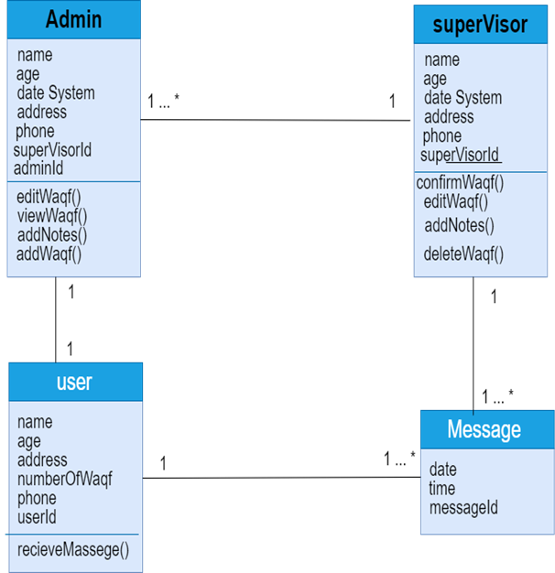

Figure ‑:Domain Diagram

# Project Analysis and Design

## Actor-goal List

|  |  |
| --- | --- |
| **Actor** | **Goal** |
| **Admin** | * **AddWaqf** * **EditWaqf** * **ViewWaqf** * **AddNotes** |
| **Supervisor** | * **ConfirmWaqf** * **DeleteWaqf** * **EditWaqf** * **AddNotes** |
| **Researcher** | * **Login** * **SignUp** * **FilterInWaqf** |
| **Client** | * **RecieveMassege** |

Table ‑:Actor Goal List

## Use Case Diagram

The diagram shows the actors and use cases of the system extracted from the functional list in section ().

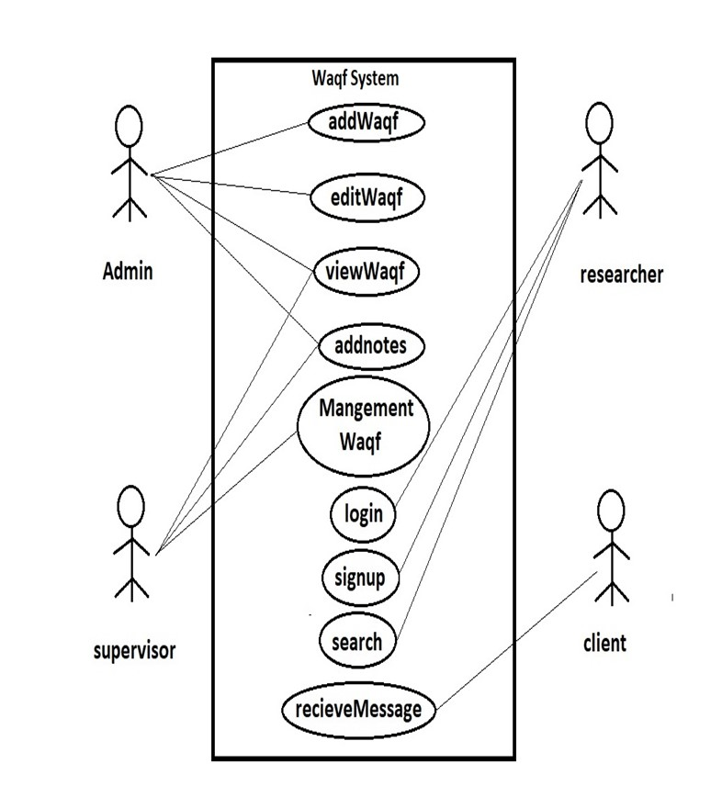

Figure ‑:Use Case Diagram

## Activity Diagram

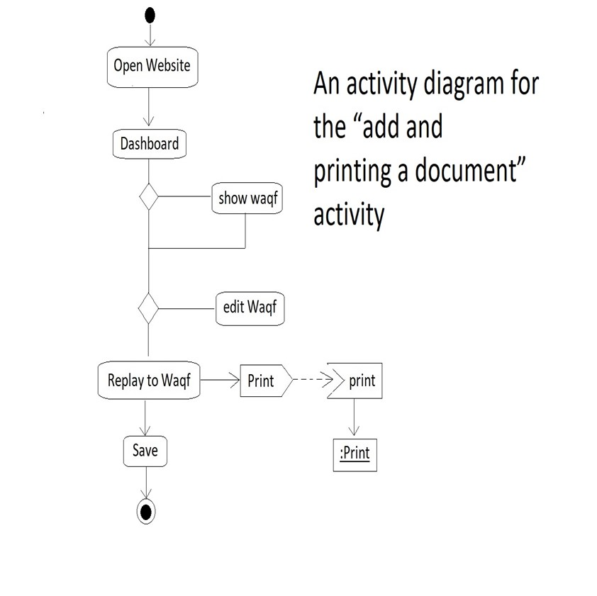

Figure ‑:Activity Diagram

## Sequence Diagrams

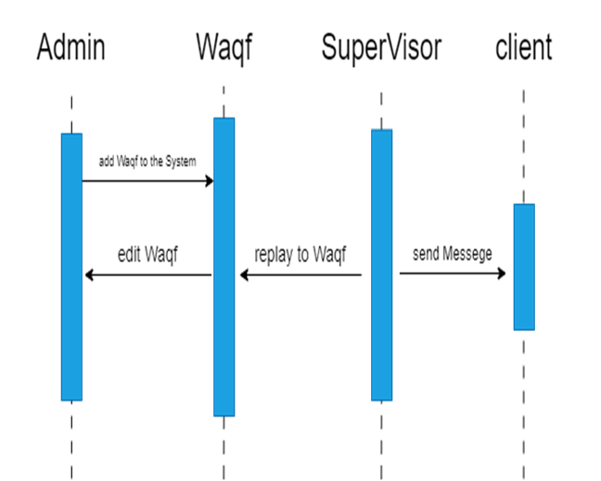

Figure ‎3‑3:Sequence Diagram

## State Diagram

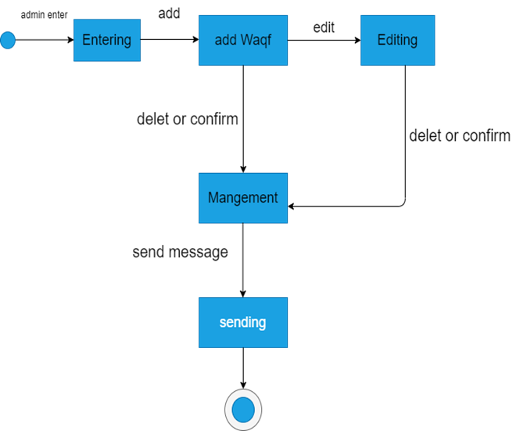

Figure ‎3‑4:State Diagram

## Design Class Diagram

Design Class Diagram: Show’s all classes in our system, which a

Figure ‎3‑5:Design Class Diagram

## Deployment Diagram

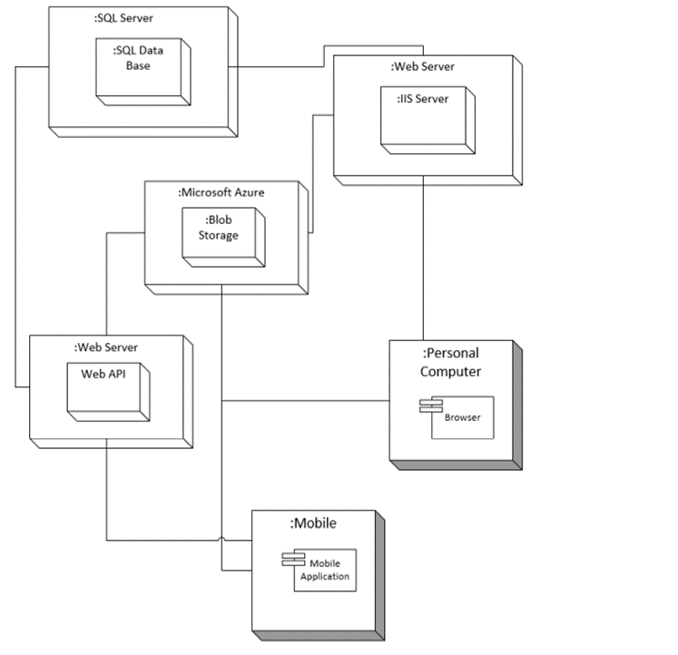

Figure ‑:Deployment Diagram

## Output & Input Design (Screens)

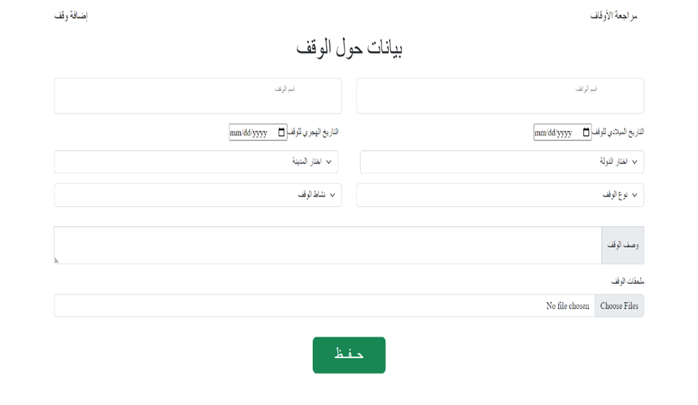The screen below shows adding Waqf Page

Figure ‎3‑7:Adding Waqf

# Implementation and Testing

**Our Project is divided into three parts:**

* Mobile App
* Website For Users
* Dashboard

## configuration code for the Mobile App

### Home screen (show all Awqaf) Waqf details (description)

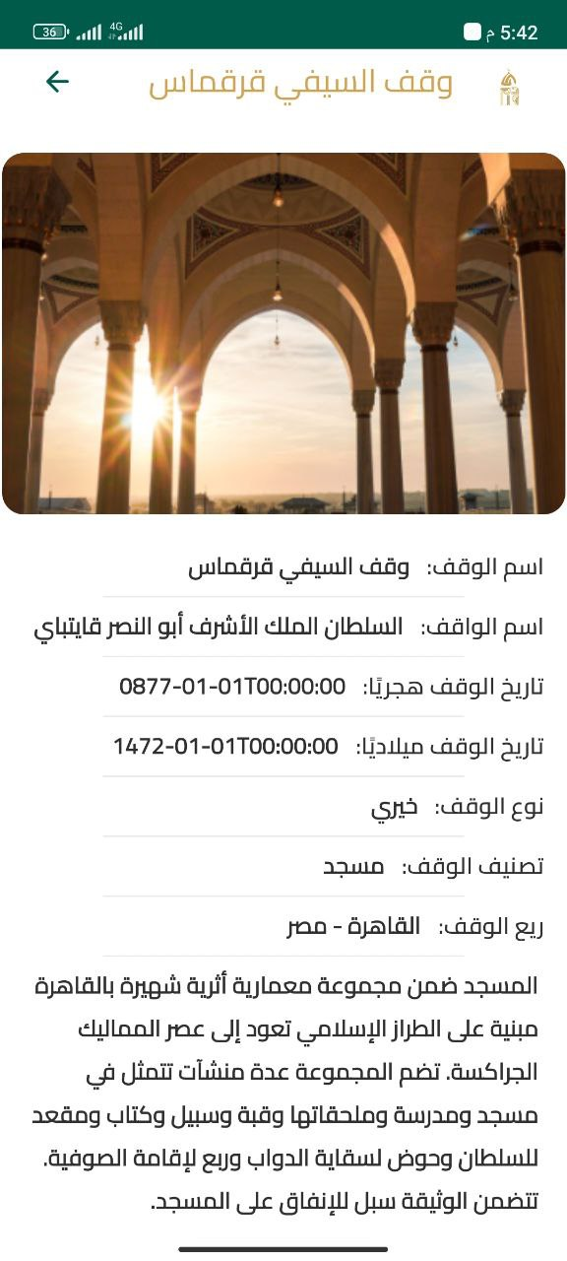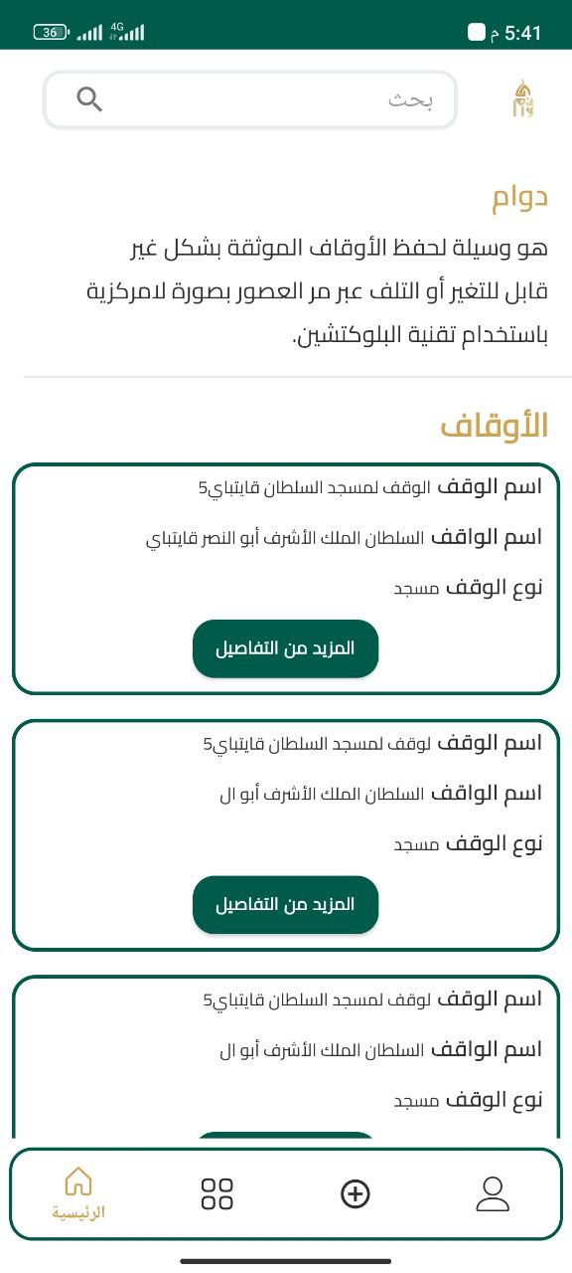

Figure ‎4‑1:Waqf details (description)

Figure ‎4‑2:Home screen (show all Awqaf)

### A screenshot of a cell phone Description automatically generatedAbout us screens Add Waqf request

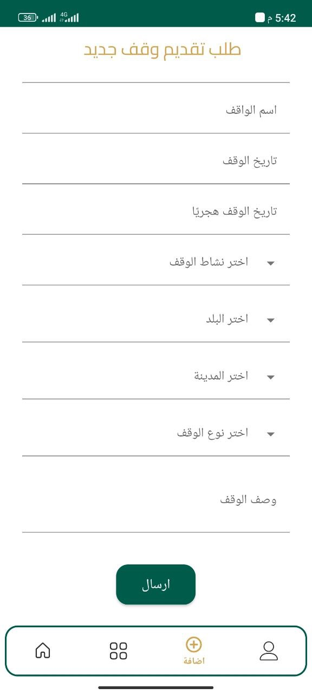

Figure ‎4‑3:Add Waqf request

Figure ‑:About us screens

### A screenshot of a phone Description automatically generatedContact us.

Figure ‎4‑5:Contact us

### Webservices used to facilitate communication between an Android application and API

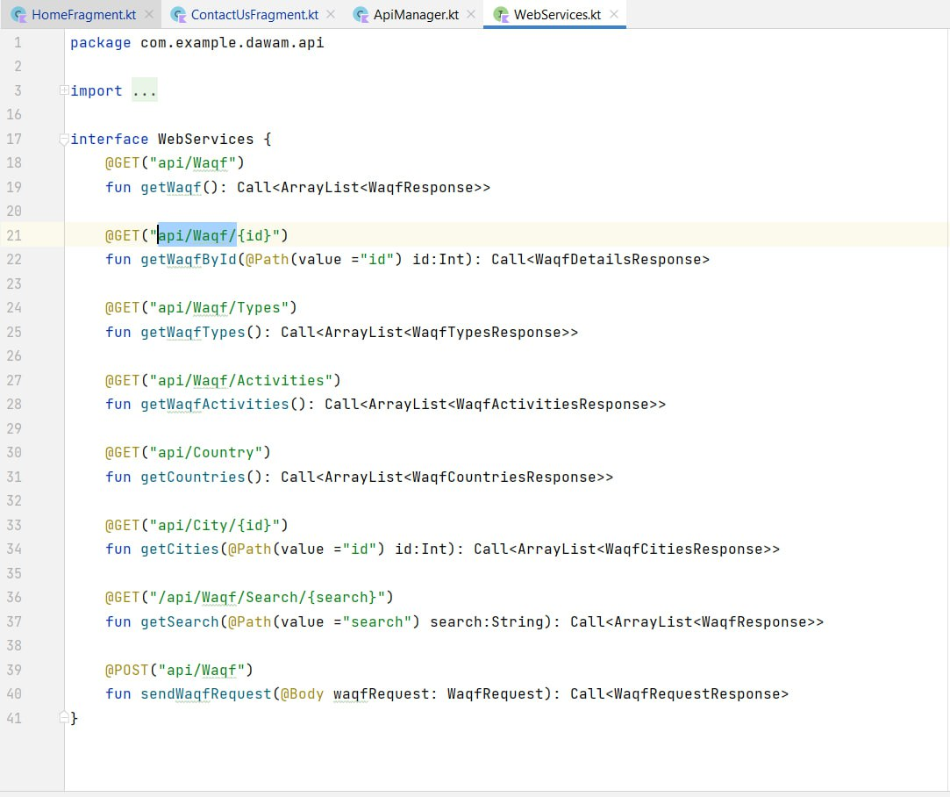

Figure ‑:Webservices

### A picture containing text, screenshot, font Description automatically generatedAPI Manager class to summons base URL once.

Figure ‎4‑7:API Manager class to summons base URL once.

### **Home fragment the location where the API is called to load AWQAF onto the home page.**

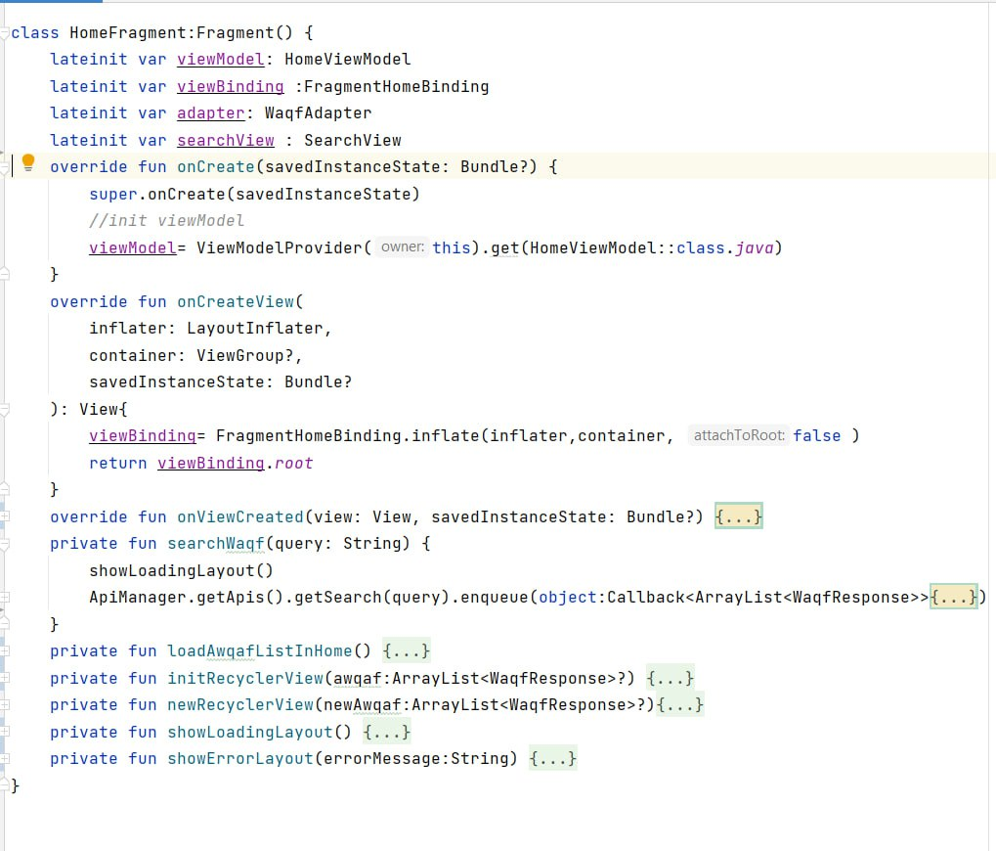

Figure ‑: Home fragment

### Apply Waqf Request Fragment used for fetching and loading items from and to the API

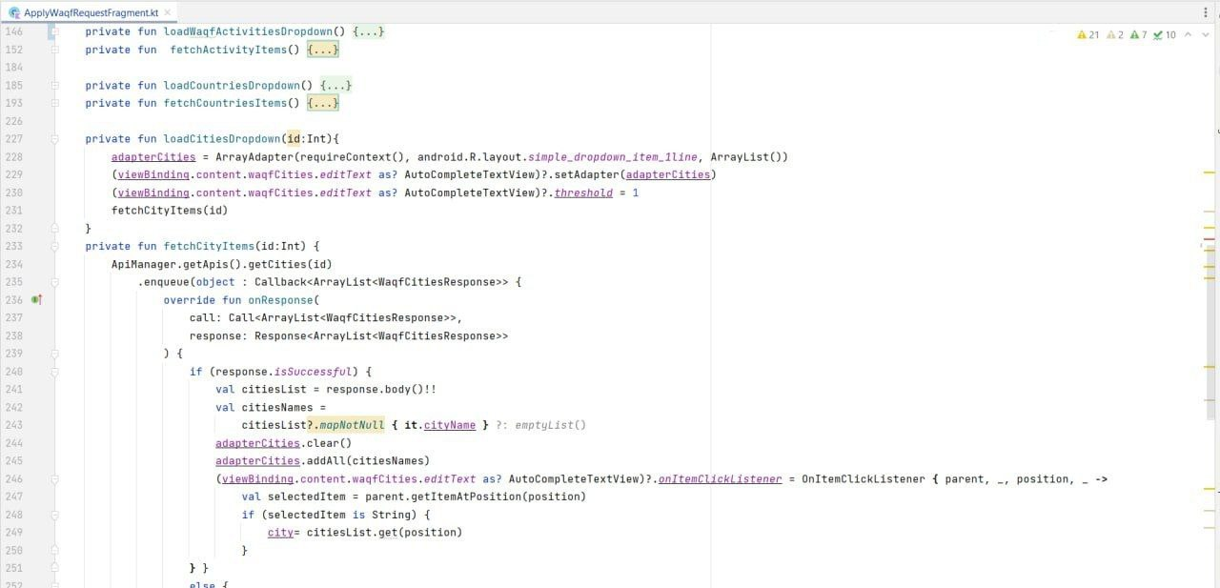

Figure ‑: Apply Waqf Request Fragment

### The Waqf Details Activity is used to display a list of awqaf on the Home page

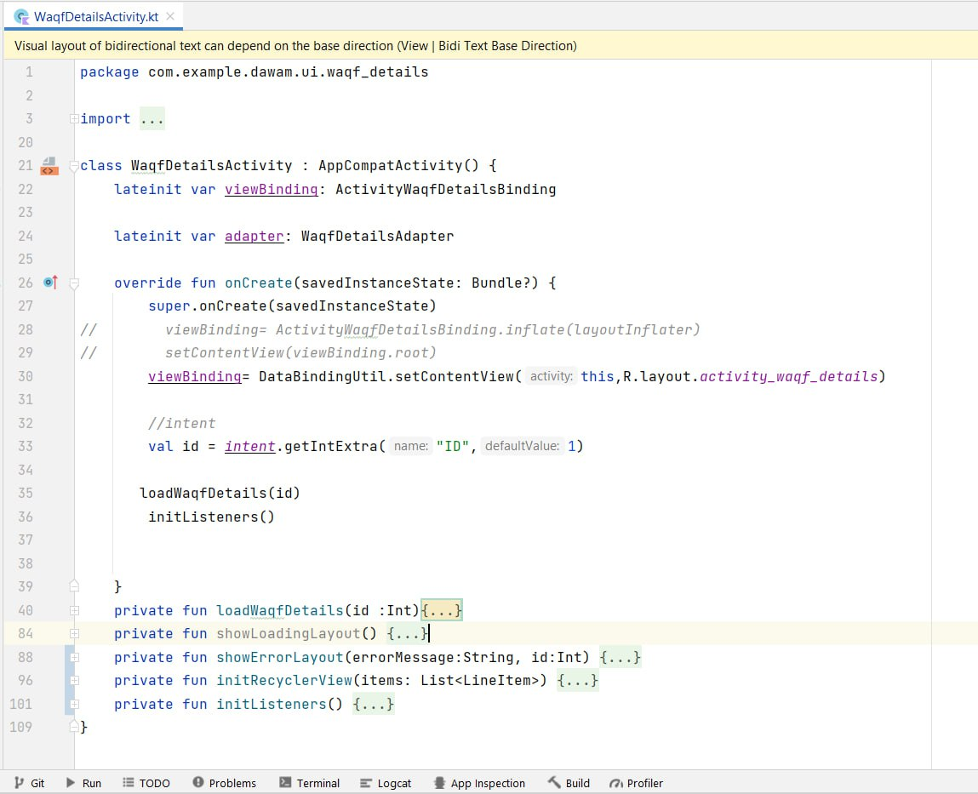

Figure ‑: Waqf Details Activity

### Implementing view binding to improve performance.

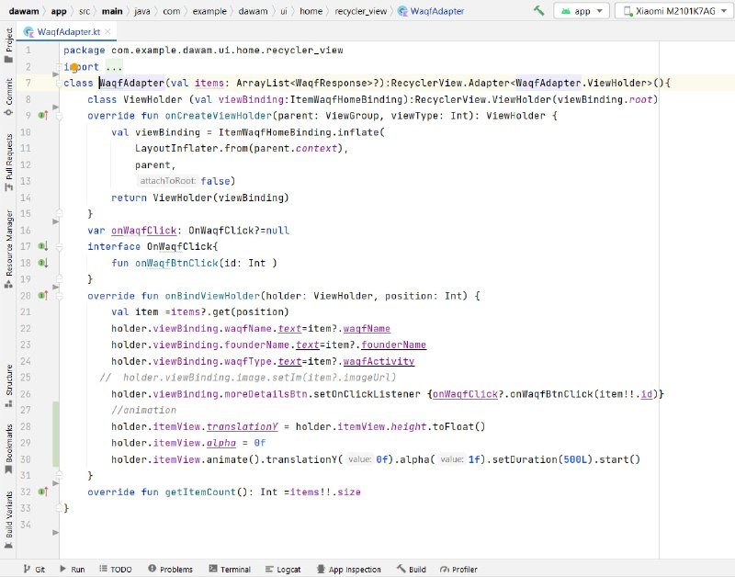

Figure ‑:Recycler view

**Front-End Part**

Our Project is divided into two separate websites one for All users to look at past waqfs and search about it.

**Technologies used at front-end:**

HTML

CSS

JS

React JS

We have used react JS framework to make website working with Single Page Application (SPA) to prevent Loading.

**Users Website**

Through this website users can reach out to Waqfs and Search about it

Users website consists of pages (Home-About-Awqaf-Search-Contac

## configuration code for the website (Front-end):

### Users Website

The SW shall illustrate: the navbar to show different options of pages that site include, and header show the name and description of website.

### A screenshot of a computer program Description automatically generatedHome Page Code

Figure ‎4‑12:Home Page Code

### Navbar Code Using Routing

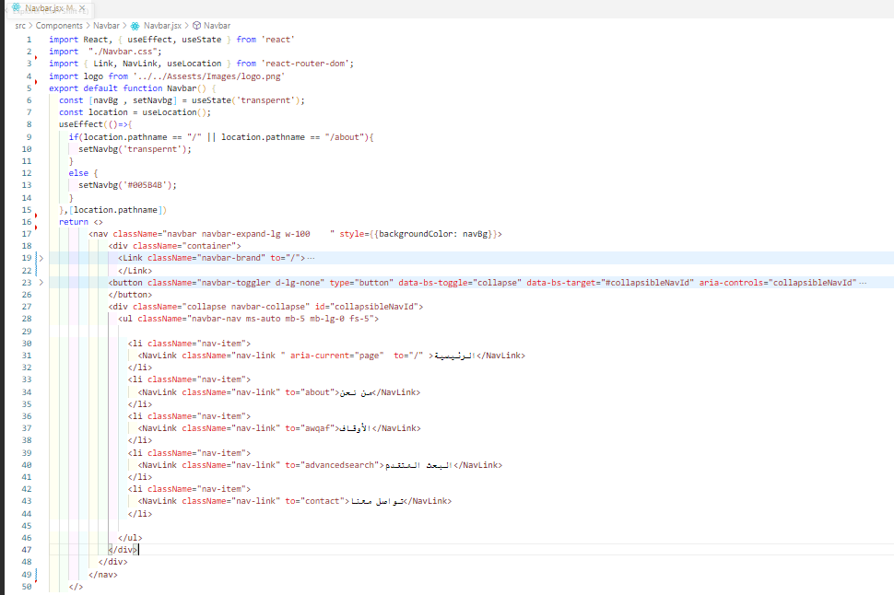

‑:Navbar Code

### Home Page

Figure ‎4‑14:showing navbar and home in website

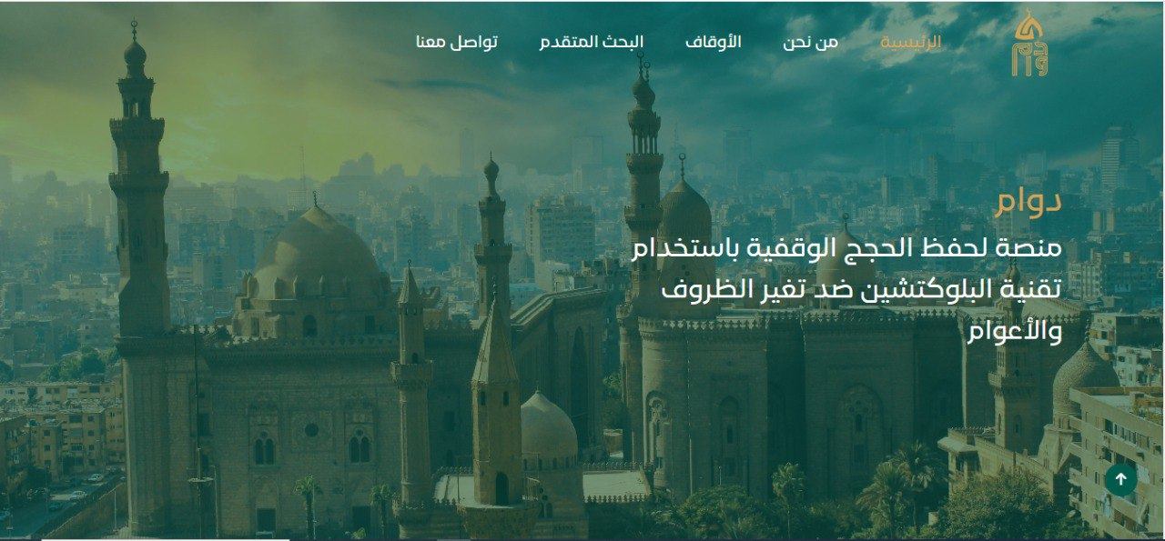

The SW shall illustrate: about section which contains an overview of the function performed by the site and some concepts of endowments and Blockchain, it include button to show more details.

### About Code

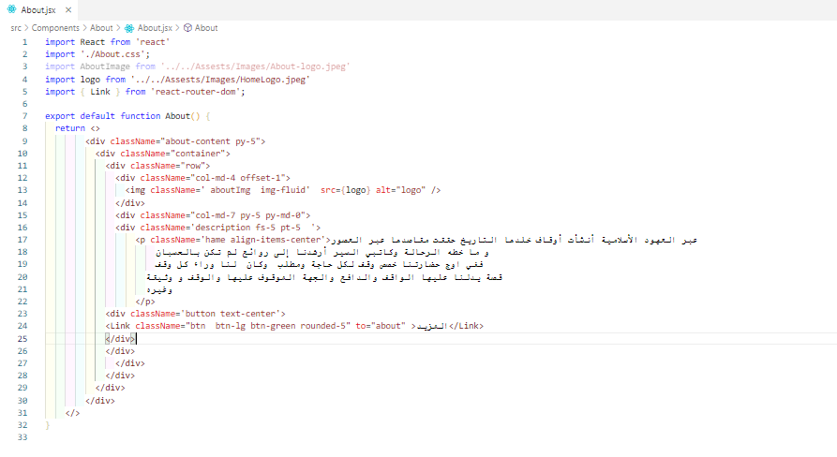

Figure ‎4‑15:about code

### About

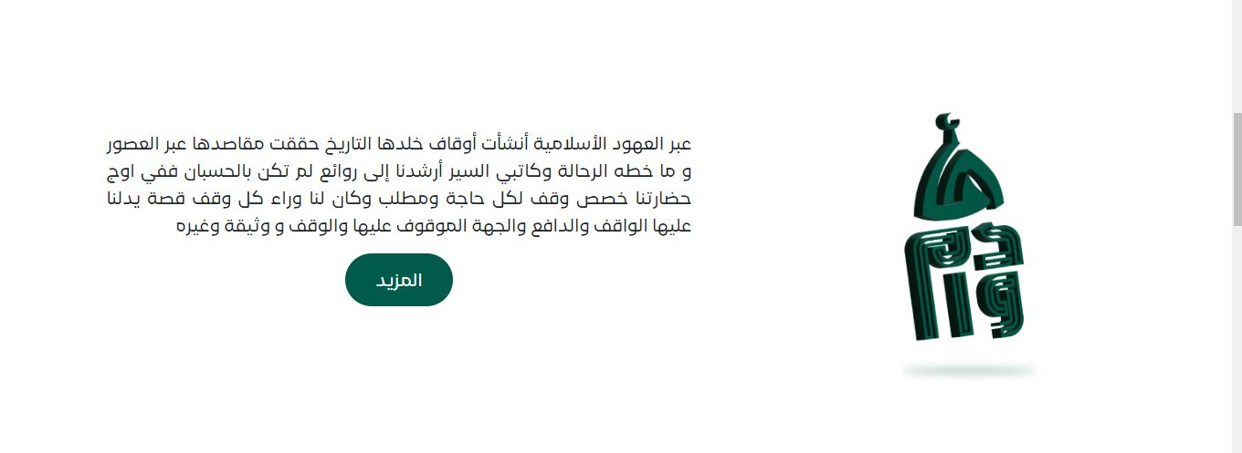

Figure ‎4‑16:showing about section in home page

### More button for switching to about page to show more information about platform DAWAM.

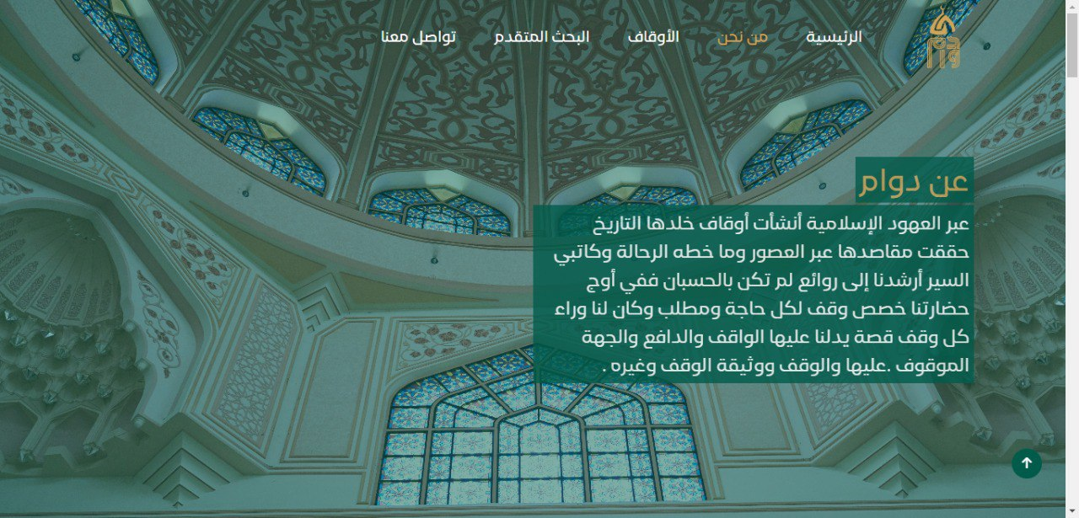

Figure ‎4‑17:Showing About page

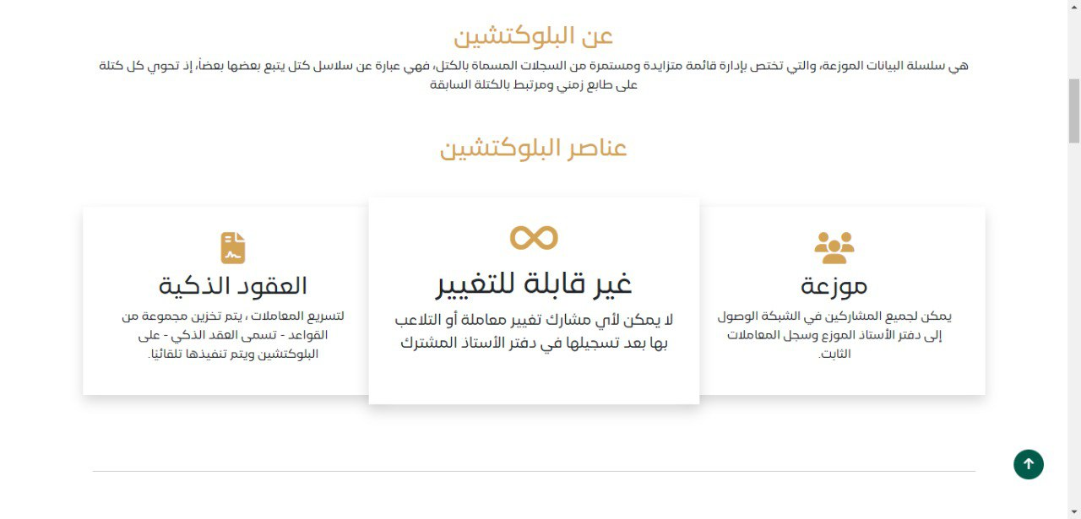

Figure ‎4‑18: About Blockchain Elements

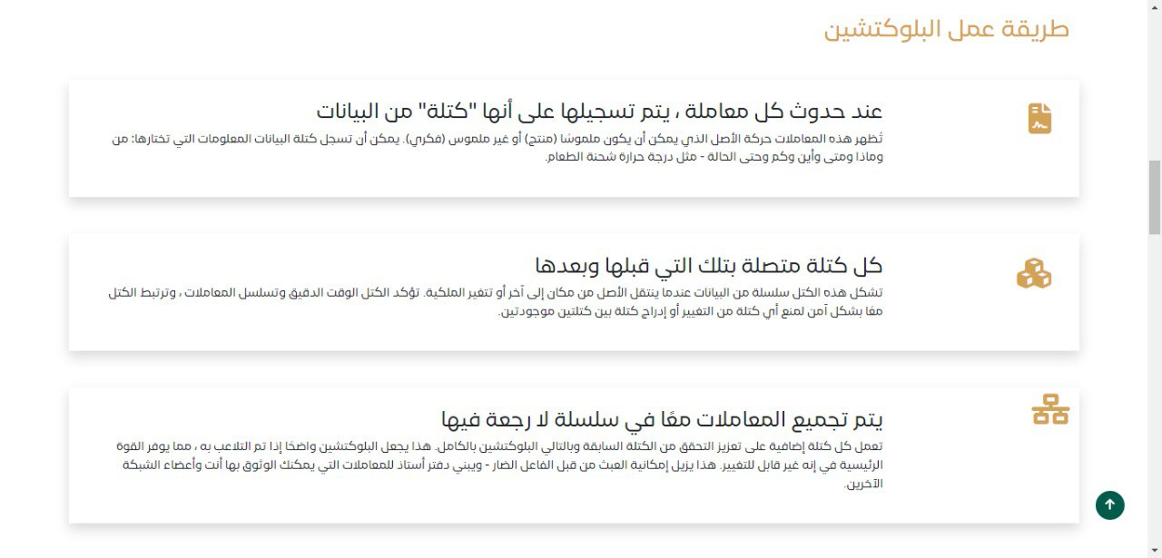

Figure ‎4‑19:How Blockchain Works

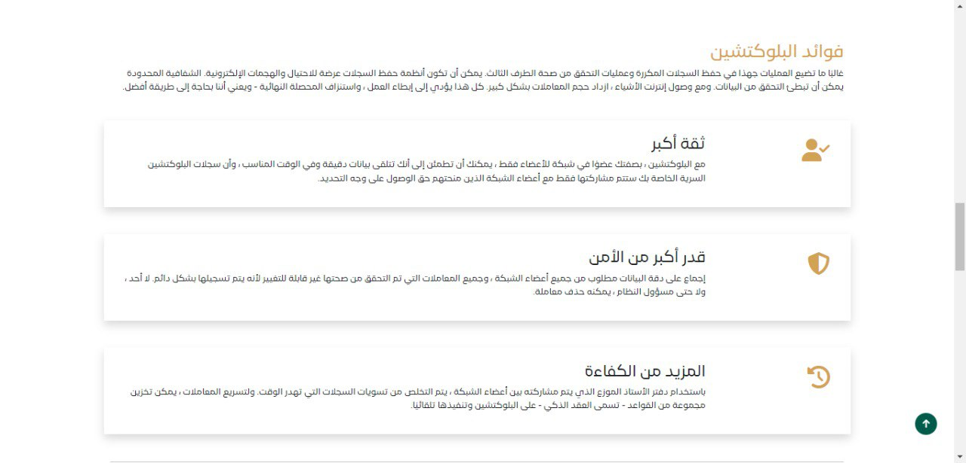

Figure ‎4‑20:Blockchain benefits

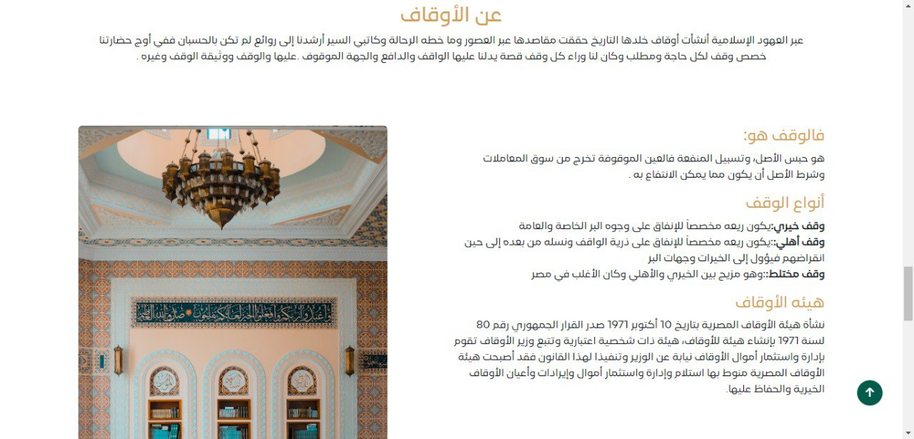

Figure ‎4‑21:About Awqaf

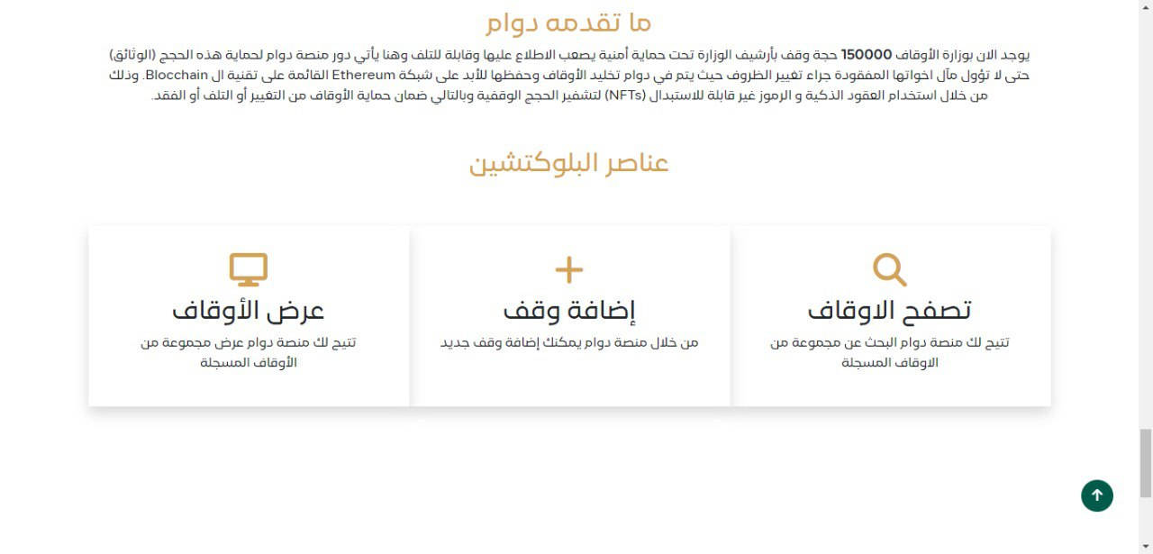

Figure ‎4‑22:DAWAM Description

### A screenshot of a video game Description automatically generatedThe SW shall illustrate: counter section at home page which count number of awqfs in world, Egypt and DAWAM platform.

Figure ‎4‑23:Counter Section

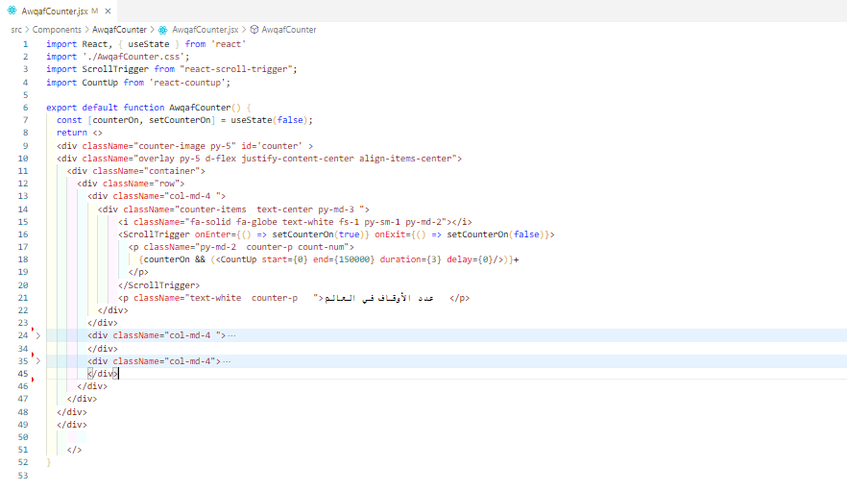

Figure ‎4‑24:Counter Section code

### The SW shall illustrate: waqfs search section which include input search to do advanced search of waqfs in DAWAM.

Which include input that transfer to Advanced Search page

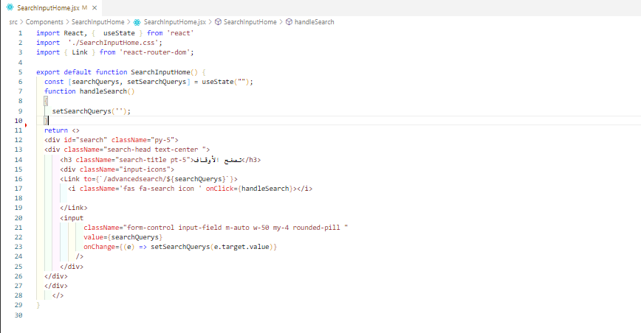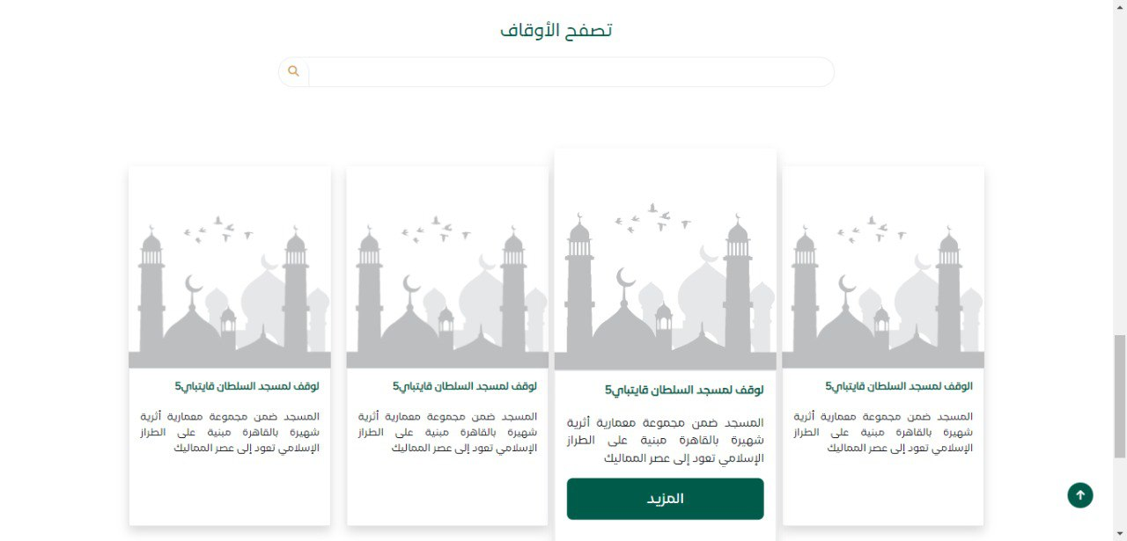

Figure ‎4‑25:Browse Awqaf

Figure ‎4‑26: Browse Awqaf code

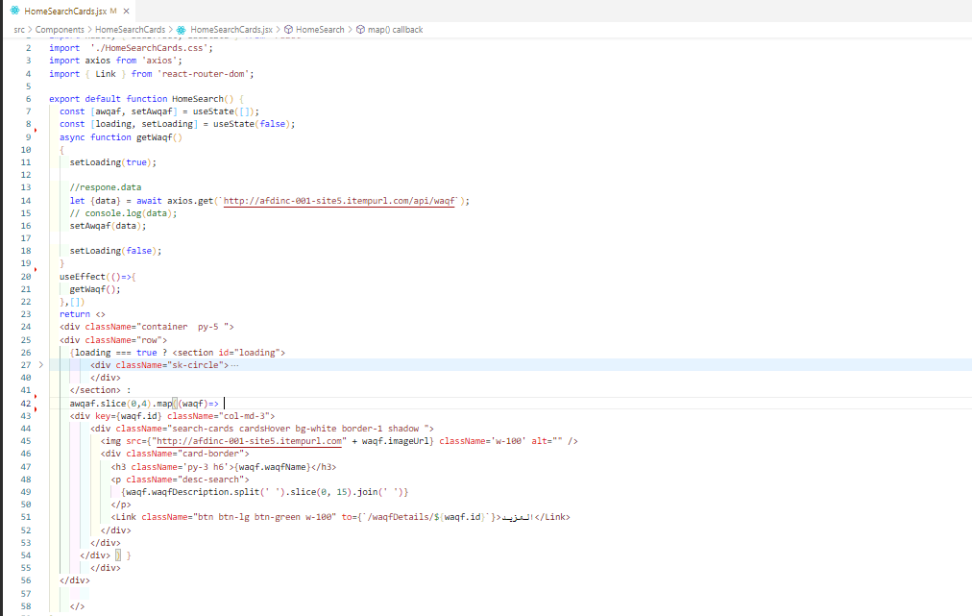

Figure ‎4‑27:Cards Code

### A screenshot of a website Description automatically generatedCards include of more button for switching to show more details about waqf

Figure ‑:Waqf Details

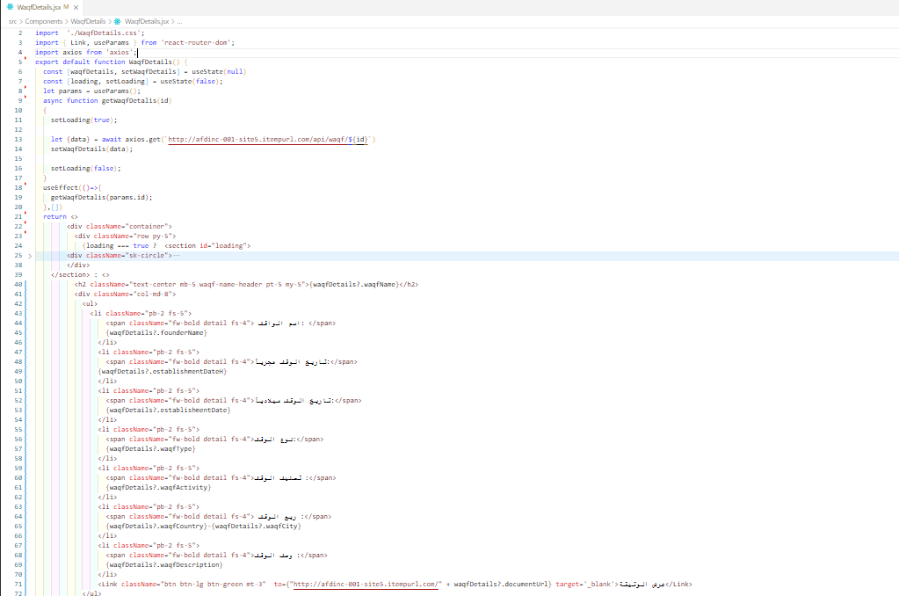

Figure ‑: Waqf Details code

### A green and white rectangular object with white text Description automatically generatedfooter

Figure ‎4‑30:Footer

### Showing Awqaf in platform

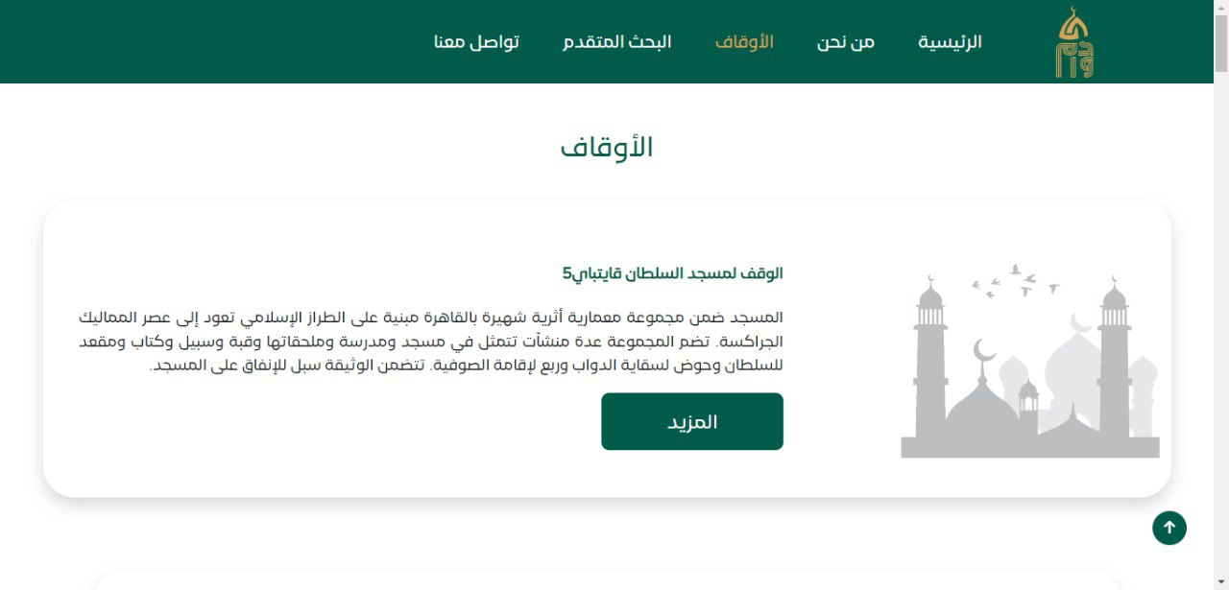

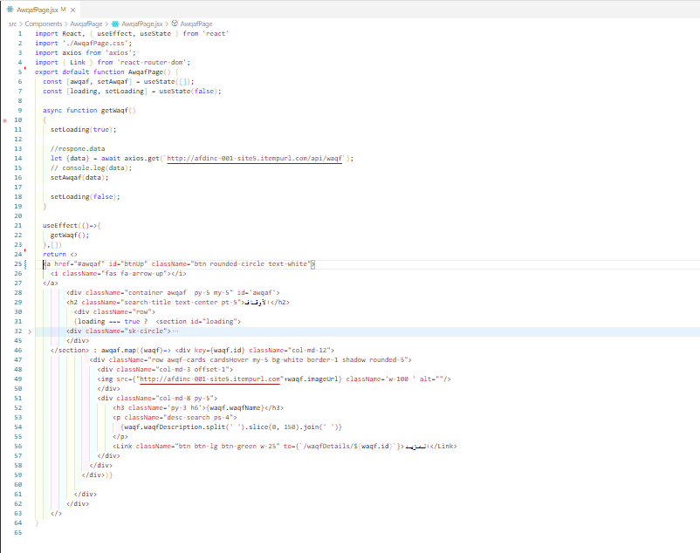Figure ‑:Awqaf Page

Figure ‑

### Contact us page

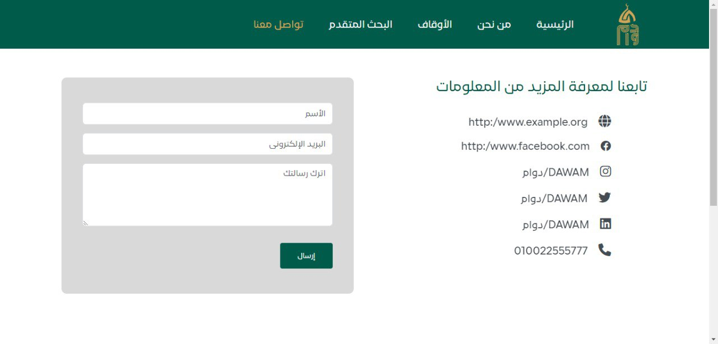

Figure ‑: Contact Us

### The website is responsive on all screens with different sizes.



Figure ‑:Laptop Screen

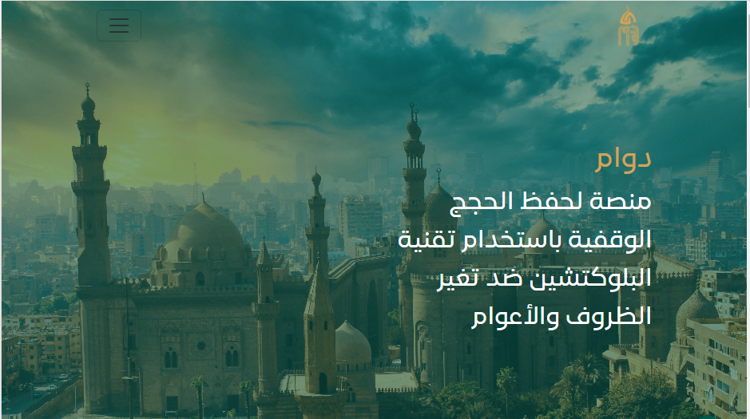

Figure ‑:Tablet Screen

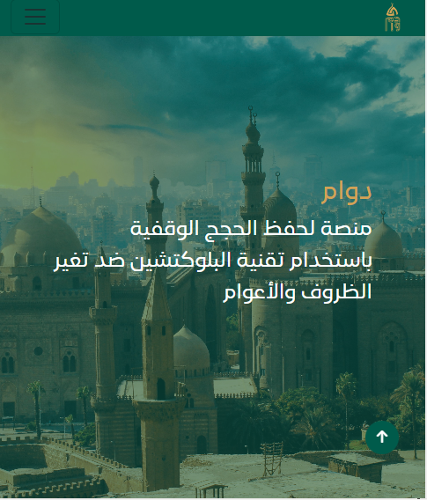

Figure ‎4‑36:Mobile Screen

### Dashboard Website

For Supervisors and Admins

### Dashboard

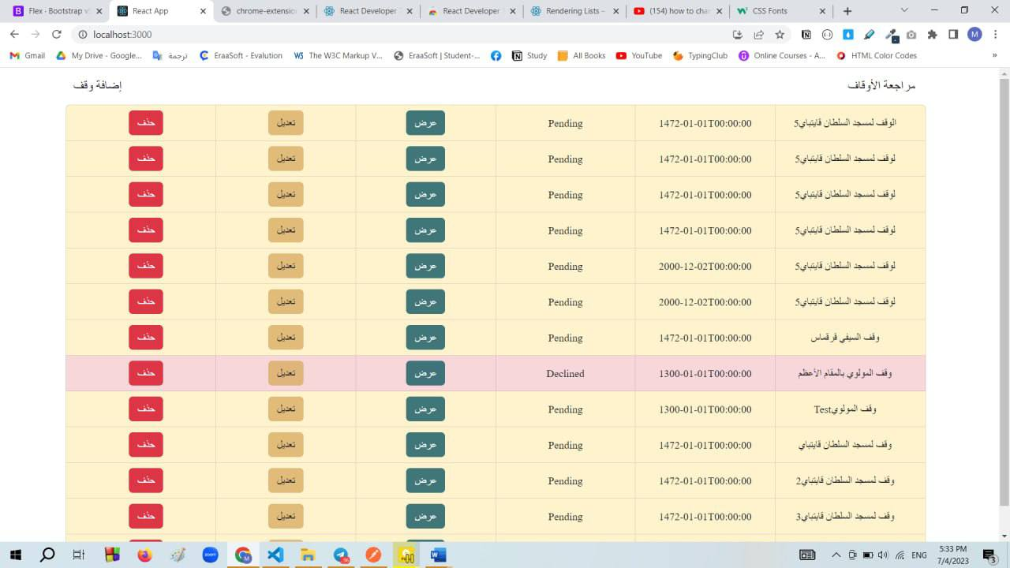

Figure ‎4‑37:Add Waqf

### A screenshot of a computer Description automatically generatedAdd Waqf

Figure ‎4‑38:Add waqf

## configuration code for the website (Back-End):

### Database mapping

Database was created with code first model with this sample diagram:

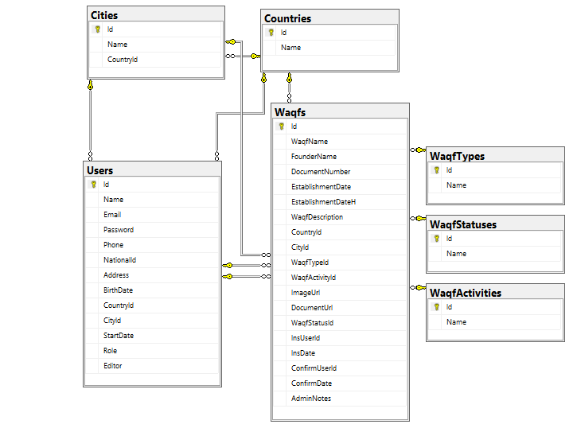

Figure ‑:Database Sample Diagram

Sample of database entities Waqf entity:

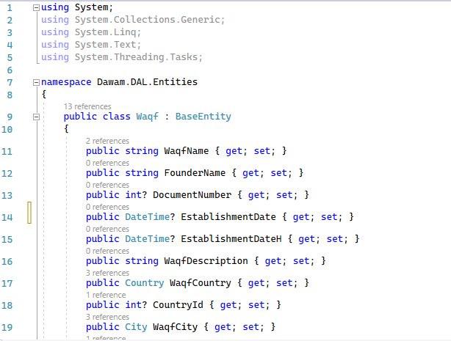

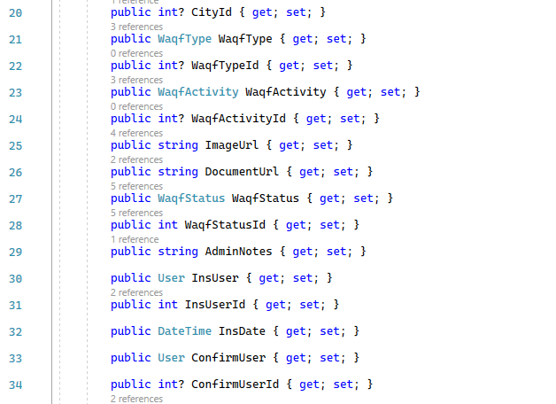

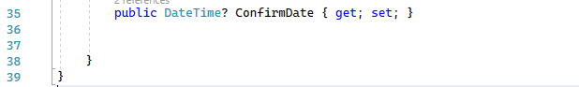

Figure ‑:Waqf Entity

### API Architecture:

API is created using three-layer project architecture for more security and maintainability the three layers are Data Access layer (DAL), Business Logic Layer (BLL) and Implementation API layer

The business logic layer use Generic and specification Design Patterns

Project Structure is shown as follows:

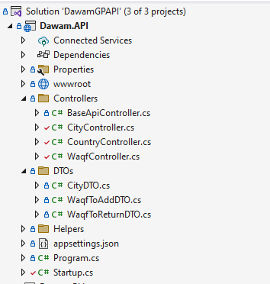

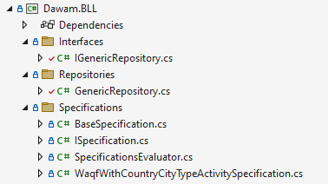

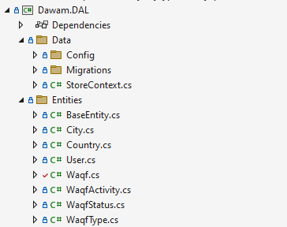

Figure ‑:Back_end Project Architecture

### Implementation sample:

Generic Repository is as shown:

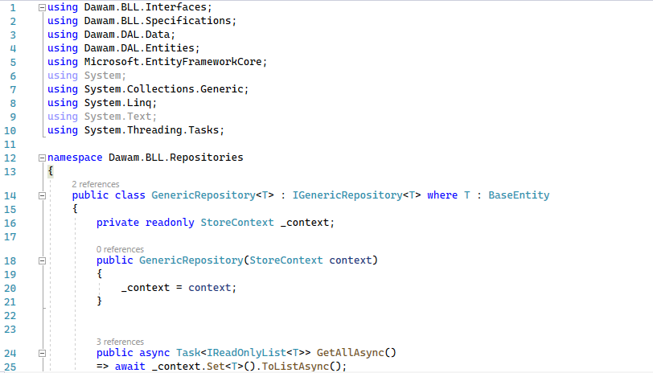

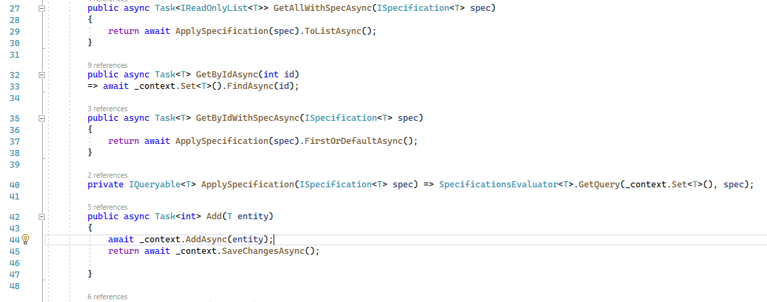

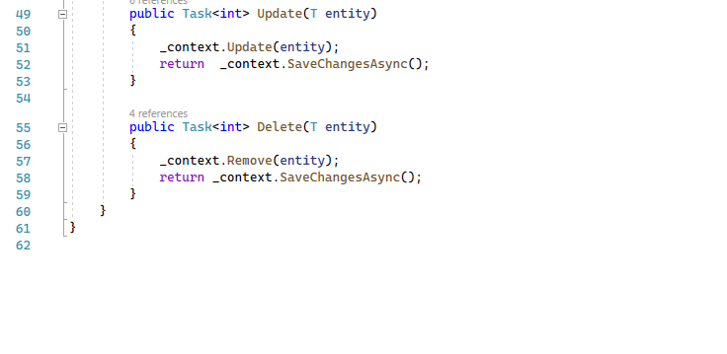

Figure ‑:Generic Repository code

### API Controller model:

And as a sample waqf controller is as shown:

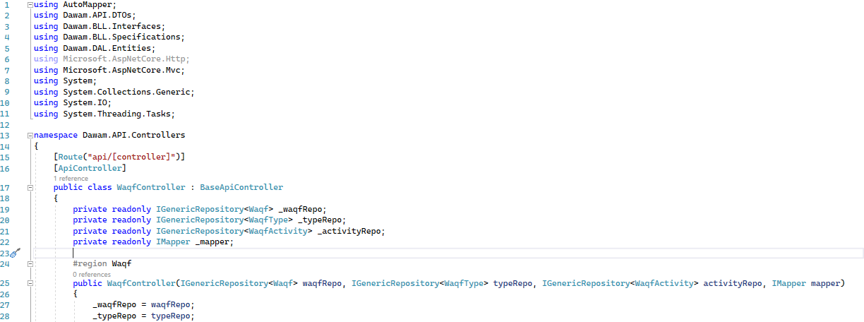

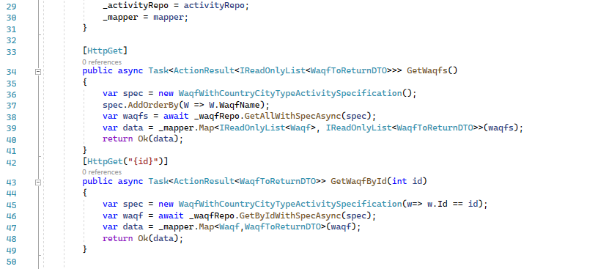

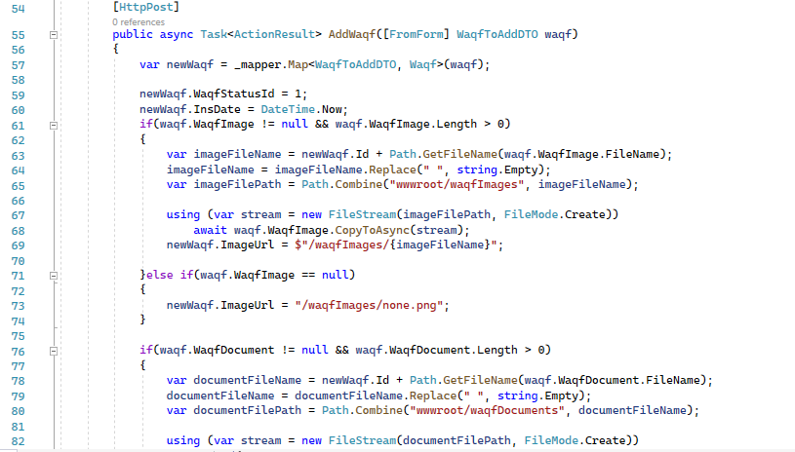

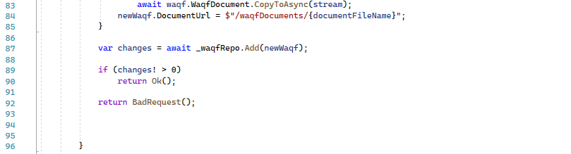

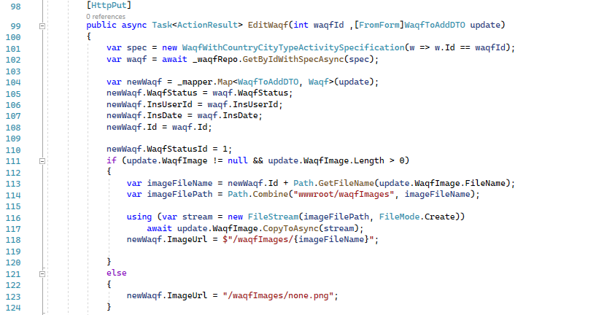

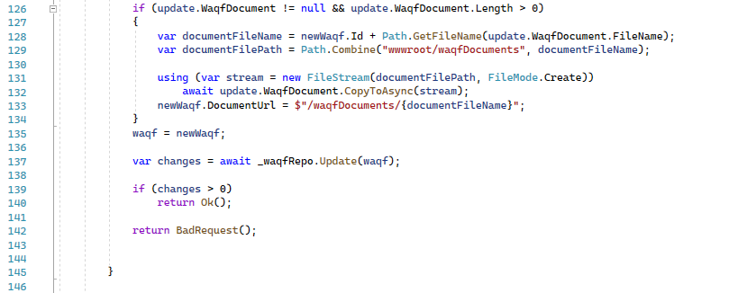

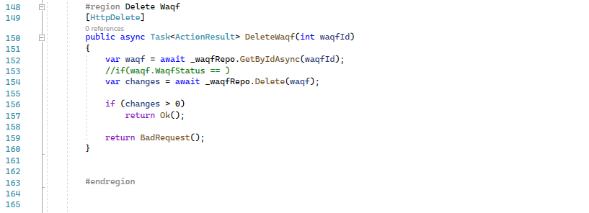

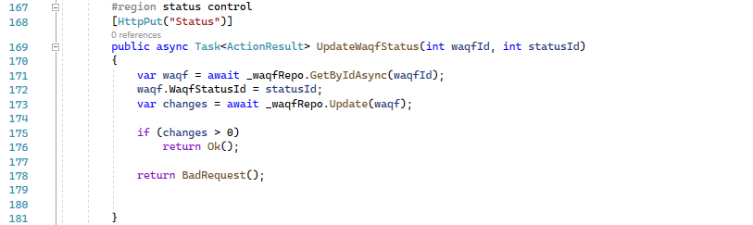

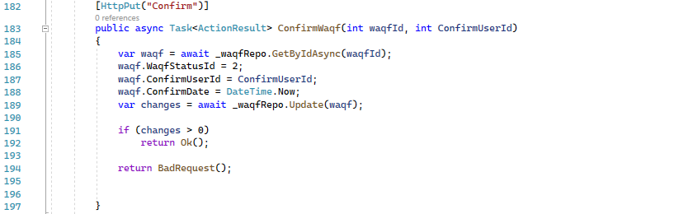

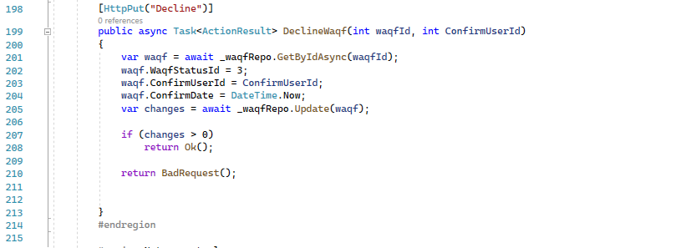

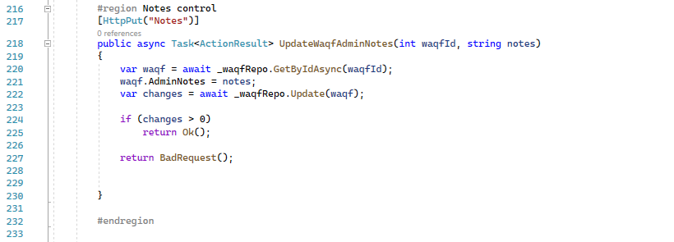

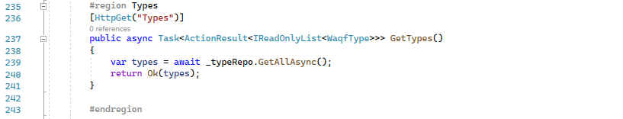

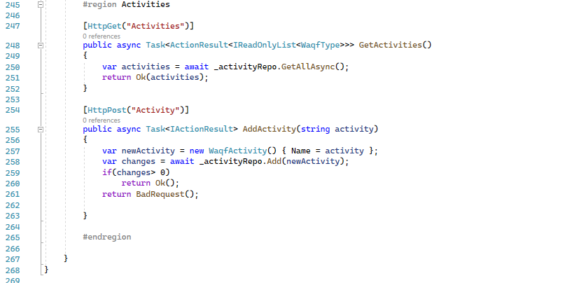

Figure ‑:waqf controller code

### ERC721 NFT creating smart contract sample:

Figure ‎4‑44:ERC721 contract code

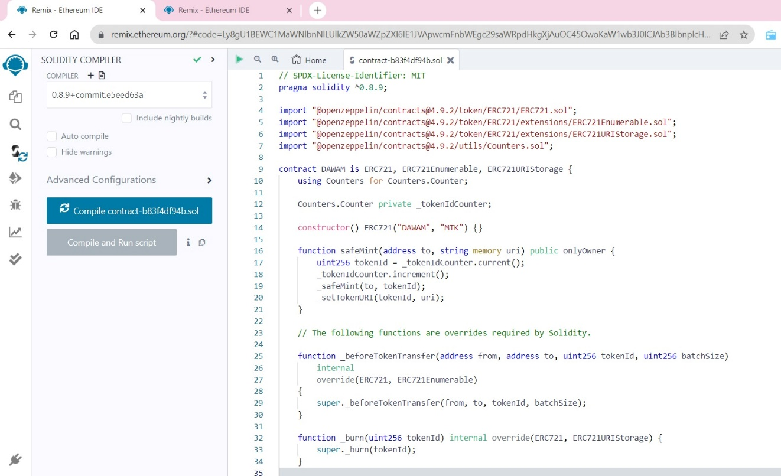

## Configuration code for the website (Blockcahin):

A solidity smart contract was developed with ERC721 standards to create the NFTs from the documents

### Solidity smart contract with ERC721 standards:

Figure ‎4‑45:ERC721 contract code

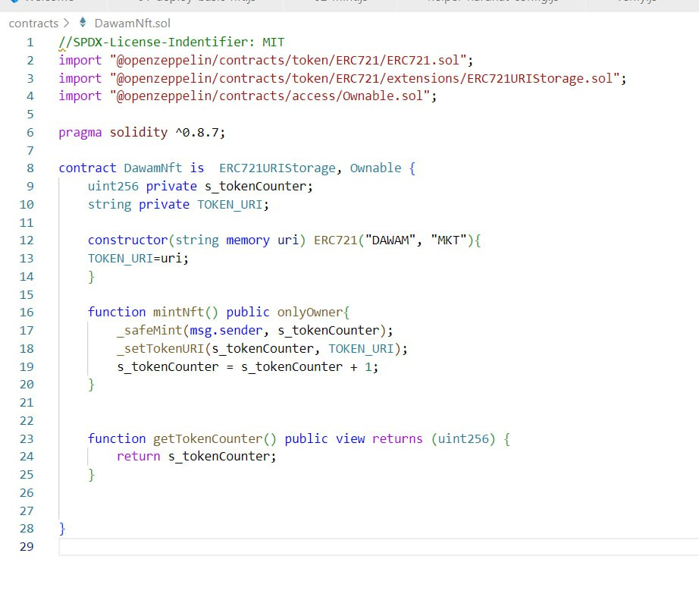

### Deploying the smart contract with hardhat framework:

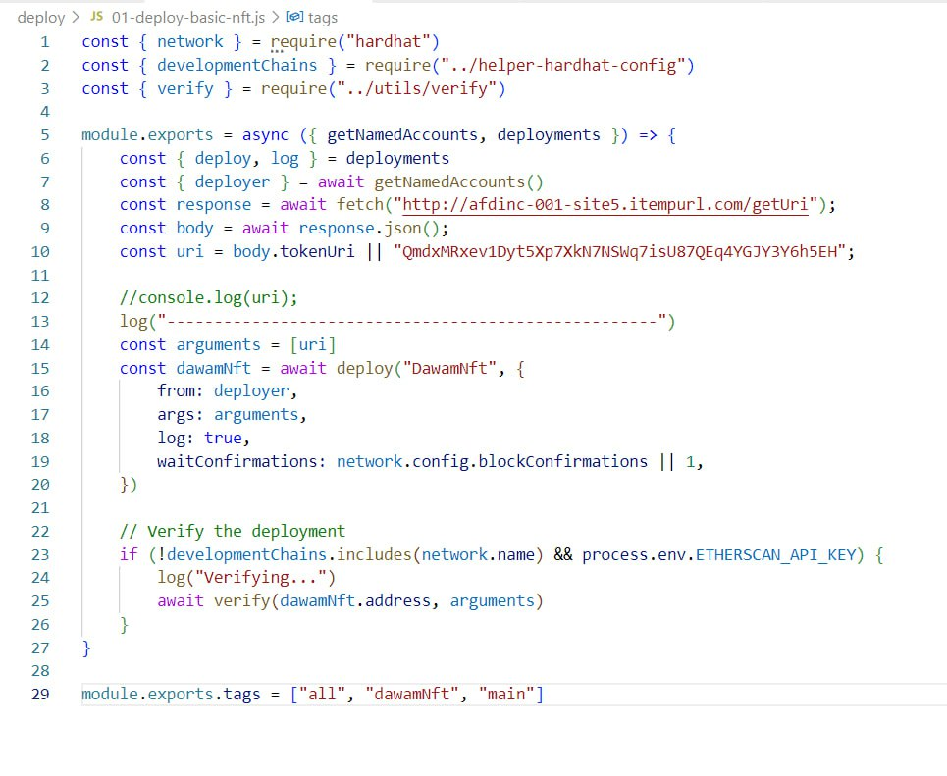

Figure ‑: Deploying smart contract with hardhat

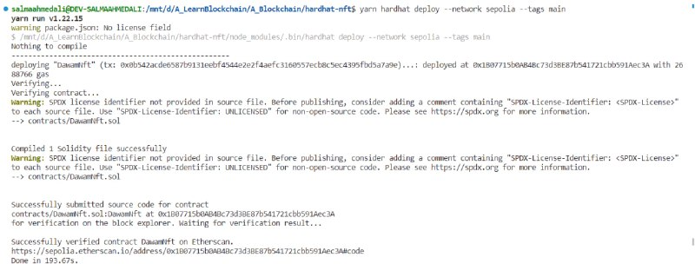

Figure ‑: deploy terminal output

### Calling mint function to mint waqf NFT:

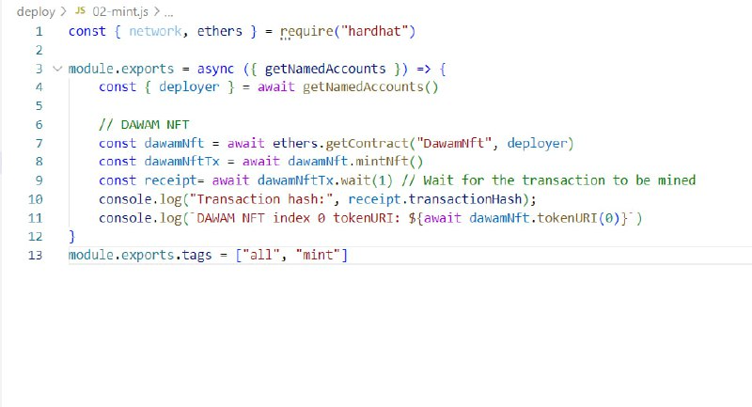

Figure ‑: mint function to mint waqf NFT with metadata URI

### Uploading metadata file to IPFS :

Document file is uploaded to IPFS to be stored in a distributed immutable way then the IPFS document hashed content identifier is added to the metadata json file then the json file is also added to the IPFS and we use its content identifier as our NFT URI

Files are added to IPFS from our Backend API using Infuria

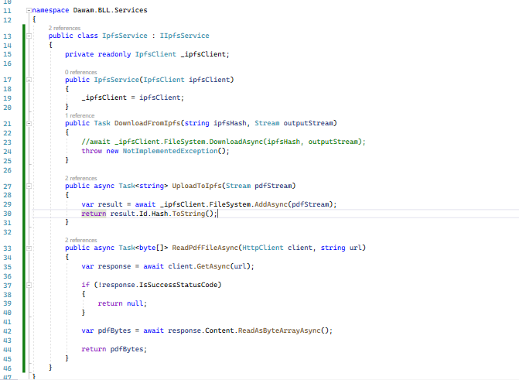

Figure ‑: managing IPFS from API BLL

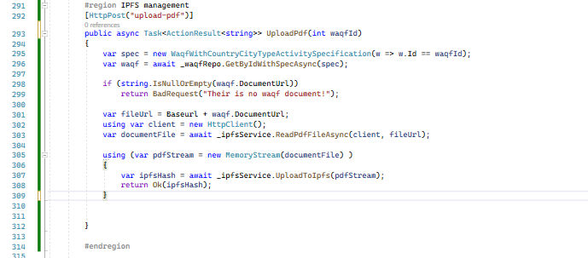

Figure ‑: managing upload API end node

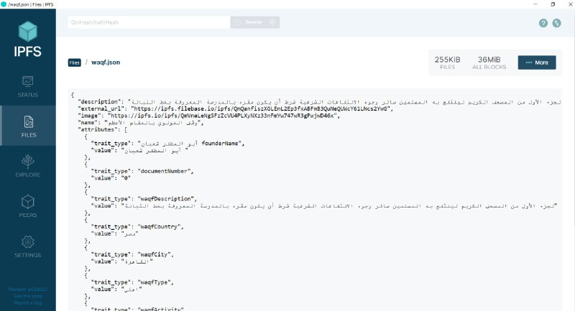

Figure ‑: metadata json file sample from IPFS

### Unit testing the smart contract:

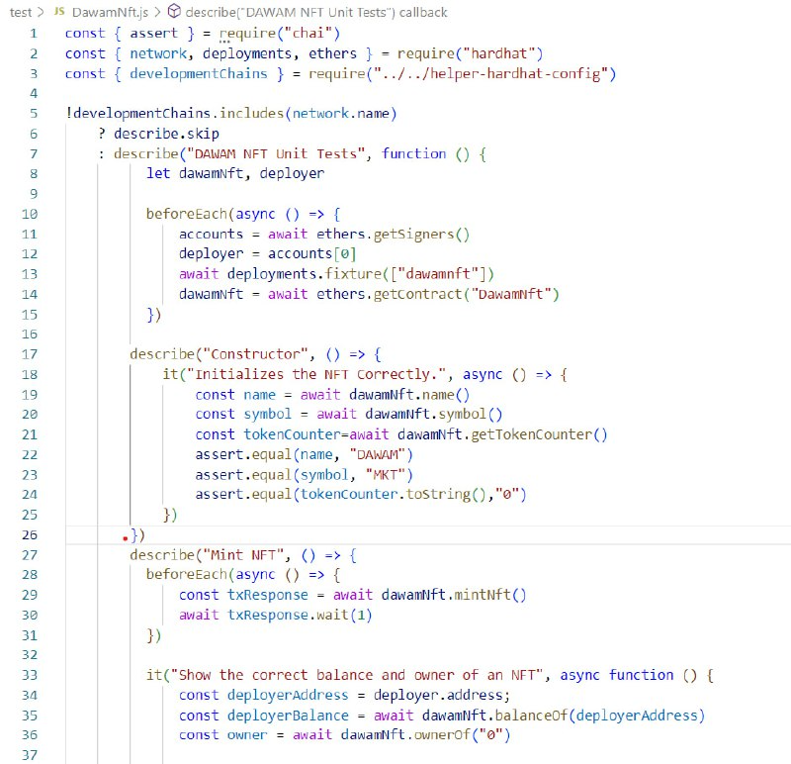

Figure ‑: smart contract unit test

### Exploring the waqfs NFTs on opensea.io:

Anyone in the world can explore the NFTs from any NFT store website (or with the contract address) like opensea.io

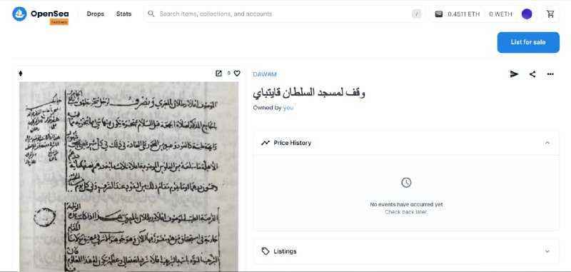

Figure ‑: exploring waqf NFT on opensea.io

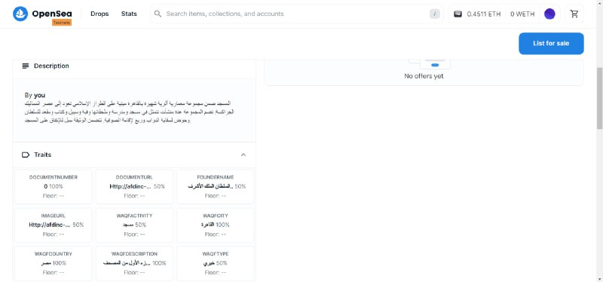

Figure ‑: explore NFT metadata on opensea.io

# Conclusion and Future Improvements

## Conclusion

The system for saving Waqf documents using blockchain technology has the potential to revolutionize the way in which these important historical records are preserved and accessed. By leveraging the security and transparency features of blockchain technology, the system can provide a secure, reliable, and user-friendly environment for storing and managing Waqf documents.

Through the research and development of this project, we have identified the key challenges faced in preserving Waqf documents and how blockchain technology can help overcome these challenges. We have also defined the functional and non-functional requirements for a system that can effectively preserve Waqf documents using blockchain technology.

The system developed as part of this graduation project book provides a proof-of-concept for the use of blockchain technology in preserving Waqf documents. It demonstrates the potential for this technology to provide a secure and efficient way to manage and access these important historical records.

## Future Work:

One of our project advantages is that we use future technology that could be expanded and implemented in different fields.

We can improve and expand our project in two ways, first: we can use it to secure other documents such as documents for land registry, real states, property contracts and university documents and more.

The second way is to add more smart contracts to our waqf project to support investing in waqf project With the trusted autonomous smart contracts for crowdfunding.

## References

Al-Salahat, S. M., 2021. Endowment and Blockchain Technology: Invest and Finance from the Sharia Perspective.

Sasse, H., 2019. Use of Blockchain Applicationsin Developing Waqf: A Platform by Finterra Companies as aModalStudy. *Journal of Islam in Asia,* pp. 20-29.